

Final project proposal report

Faizan, Sekhar, Tom



October 11, 2022

Clark university

MSDA 3999

Table of Contents

Capstone Project - Final Project Proposal Report 2

Introduction 3

Business Questions 4

Objective 5

Problem Statement 5

Project Goals 6

Exploratory Data Analysis (using Python) 6

Timeline 15

Data Pre-processing and Modelling 16

Problem Statement 16

Data Description 16

Data Pre-processing 16

Null checks 16

Dates Extraction 17

Label encoding 19

Feature Selection 20

Target Feature Description 21

Data Split 21

Scaling 22

Modelling 24

Linear Regression: 24

Result & Conclusion 24

Cross Validation 24

Results & Conclusion 25

Shrinkage Methods – Ridge Model 25

Results & Conclusion 25

Lasso Model 25

Results & Conclusion 25

Huber Model 26

Result & Conclusion 26

XGB Model 26

Result & Conclusion 26

Models Comparison 27

Dashboards and Story 28

Executive Overview 28

Sales Performance 30

Regional Analysis 31

Customer Segmentation 32

Product Overview 33

Sales Forecast 34

Superstore Story 34

Appendix: 35

## 

## Capstone Project - Final Project Proposal Report

Project Topic and a brief description of project

*Identifying areas to capitalize on to optimize business growth for Shoppers Stop*

We will use the Sample Superstore(renamed as ‘Shoppers Stop’) dataset to answer a series of business questions leading to the identification of potential areas to boost business growth. Through answering the business questions, we will understand the target market, preferable shipping modes and promising geographical regions of sales.

During the data exploration phase of the project, we will identify any trends or patterns within the data, performance data, as well as any interesting or meaningful correlations between any of the data.

We will use machine learning to evaluate Shoppers Stop’s time-series sales data and forecast the company's sales for the future quarter and for a specific product. In doing this we will be able to identify where to spend money so as to optimize sales and ultimately profit.

We will create visualizations to represent our data in a readable way, and to clearly display what we have learned through the data exploration phase of our project. The visualizations will detail the reasons behind our recommendations.

Ultimately, we will present a project on the Shoppers Stop data that shows how we have worked with the dataset from start to finish. We will use numerous tools for each aspect of the project; including, but not limited to, Tableau, SQL, Python and PowerPoint. We will have a strong understanding of our dataset, the objectives, and the outcomes.

## Introduction

Shoppers Stop Vice President of Sales, Anjanika Walker, is a big believer in the power of information. She and her group have taken over one of the IT organizations analysts full-time to generate reports and analyses.

We are part of the team who will interview Anjanika early on to get some positive reinforcement.

Anjanika would like the system to provide her and the team with:

* Easy access to data
* Flexible analysis tools
* All the data in one place

Specifically, the company is looking to identify any trends or patterns within the data, performance data, as well as any interesting or meaningful correlations between any of the data, etc.

Shoppers Stop is a retail business located in the United States. They cater to mass Consumer, Corporate and Home Offices by selling Furniture, Office Supplies and Technology products.

The data set includes Shoppers Stop sales, earnings, and geography information.

Our objective is to analyze the sales data to find Shoppers Stop's weak points and growth prospects.

## Business Questions

VP of the Company Shoppers Stop has assigned us the task to analyze the dataset "Sample_superstore.xls" and present Reports and Dashboards answering the following questions:

1. What is the Total Profit?
2. What is the Total Discount?
3. What is the Total Sales?
4. What is the Total Product Quantity?
5. Which Category is Best Selling and Most Profitable?
6. What are the Top 3 selling products?
7. What are the Best Selling and Most Profitable Sub-Categories?
8. Which is the Top Selling Sub-Category?
9. What are the Gross Sales by Product?
10. Which Customer Segment is Most Profitable?
11. What are the Number of customers in each region?
12. How many Shipments modes are used?
13. Which is the Preferred Ship Mode?
14. How many orders shipped using each shipment mode?
15. How many orders shipped using each shipment mode each year?
16. Which Region is the Most Profitable?
17. What are the Net Sales by region?
18. What are the Profits by region?
19. What is the Highest Sale in each region?
20. Which City has the Highest Number of Sales?
21. What is the Net Sale by City?
22. What are the Profits by City?
23. How many distinct categories and subcategories?
24. Find the date the highest sale was made.
25. Find the date the lowest sale was made.
26. etc.

## Objective

For visualization part, our goal will to build multiple dashboards using Tableau and come up with a story with some interesting facts that will help the leadership to make strategic decisions.

We plan to have the following dashboards:

* Introduction
* Executive summary
  + KPI’s: Total Discount, Overall Profit, Total Quantity and Total Sales
  + Sales information: Monthly sales/year
  + Profit information: Monthly profit/year
* Customer Segmentation: Who are the top customers, how did they change over the years/months?
* Territory Analysis: Where are top customers located, what are the current sales territories, and how balanced are they? How does this map to sales regions.
* Growth Analysis: Overall market, new products, new geographies, new salespeople.

## Problem Statement

Regression will be used to create a machine learning model. The model can forecast future sales of the company or product based on historical time series data of that company, which is required to estimate sales of Shoppers Stop. In order to forecast the company's sales for the coming quarter and for a particular product, we will analyze a company's time-series sales data in this project.

## Project Goals

* Examine the daily sales data and understand the impact of external factors.
* Conduct data analysis to identify outliers, missing values, and attribute selection.
* Develop predictive models using sales data and significant external factors.
* To compare the performance to baseline models, R-square and Root Mean Square Error will be used.
* We will use linear regression and extreme gradient boosting regression for this project, and examine the results using data from the training and testing sets.

## Exploratory Data Analysis (using Python)

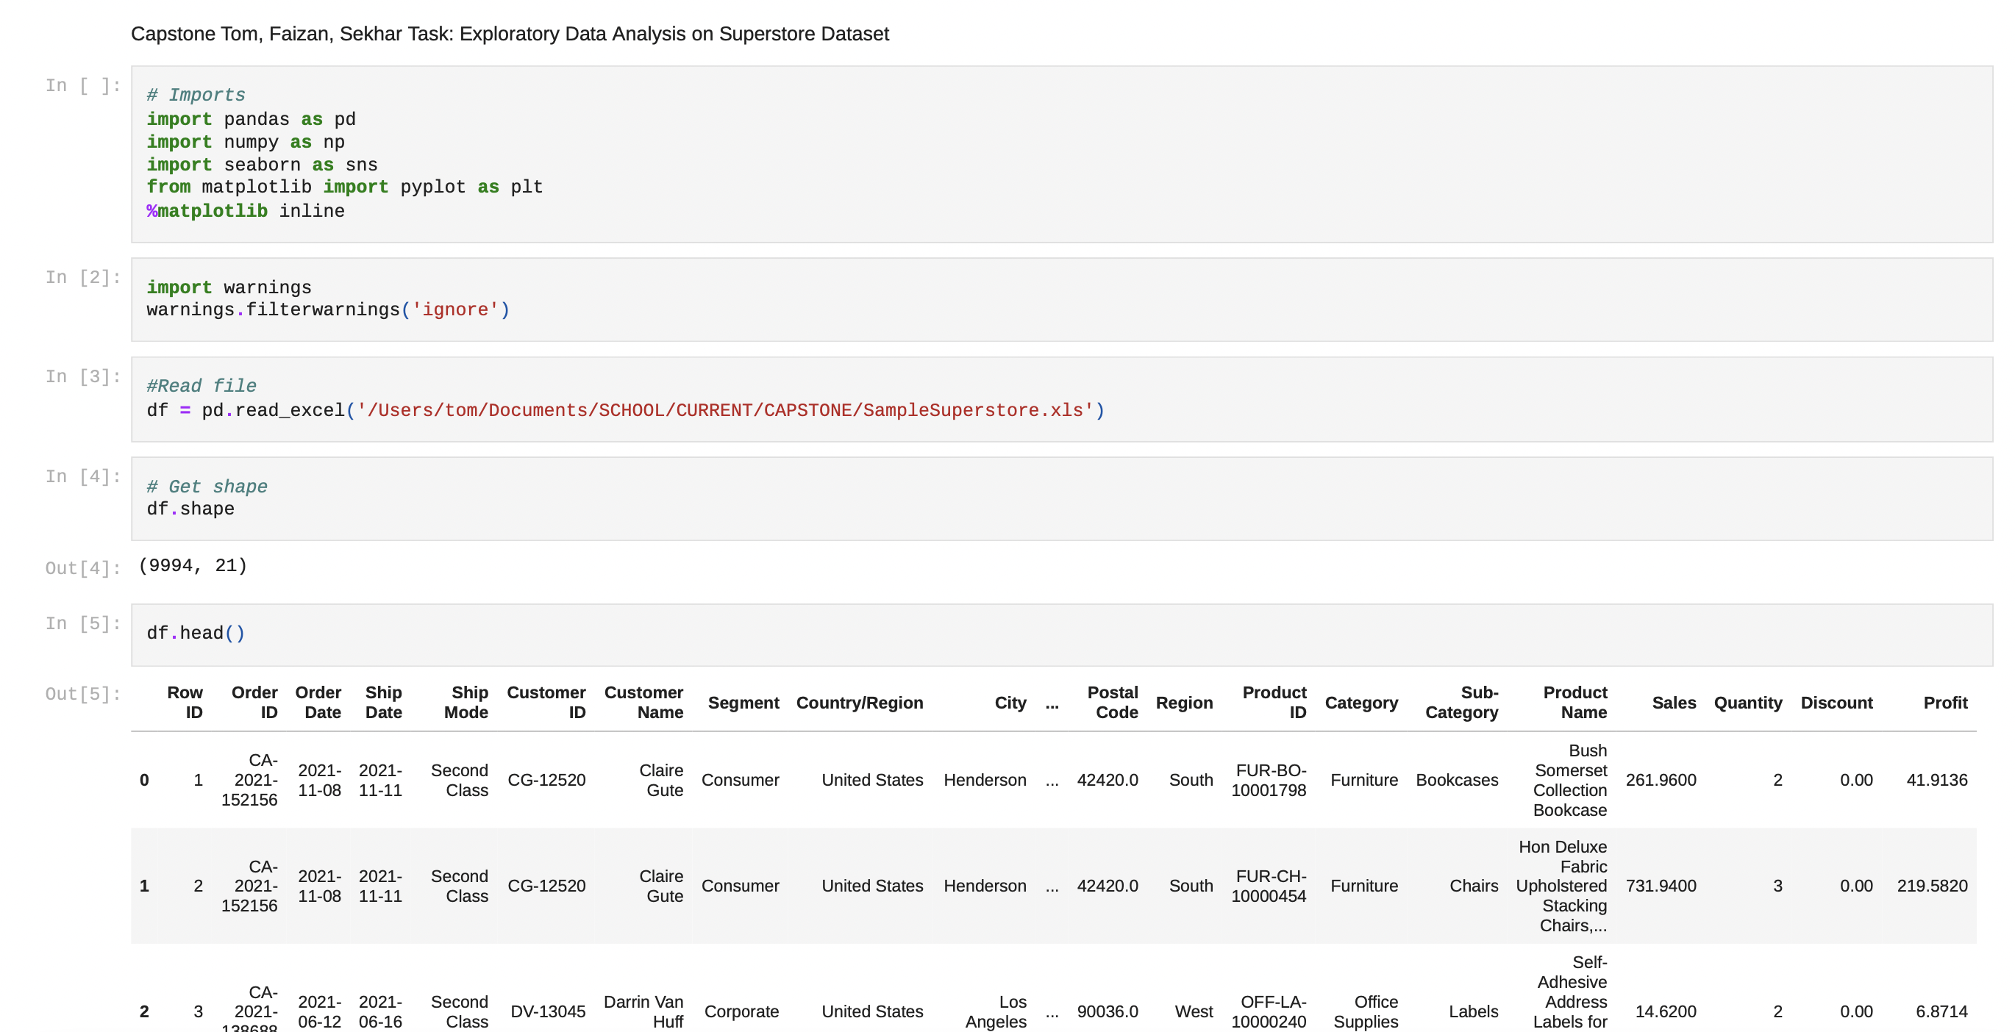

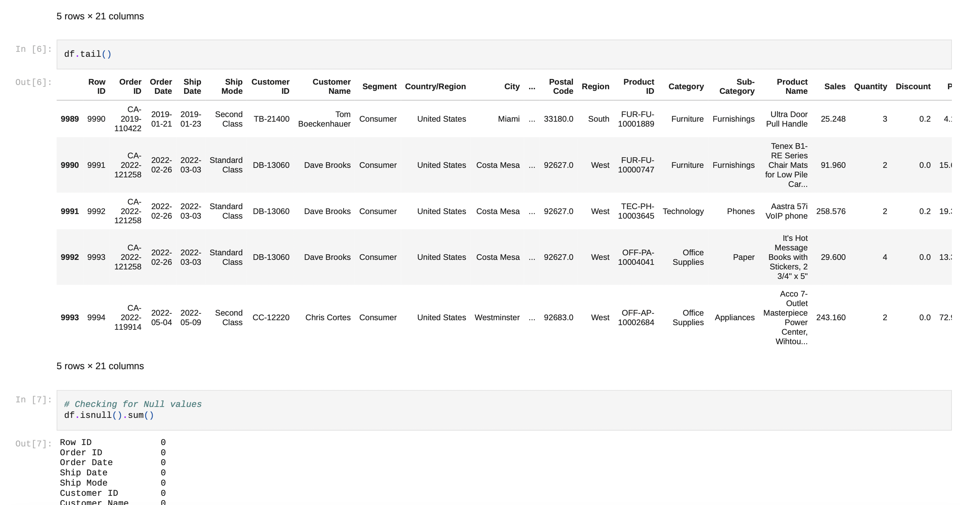

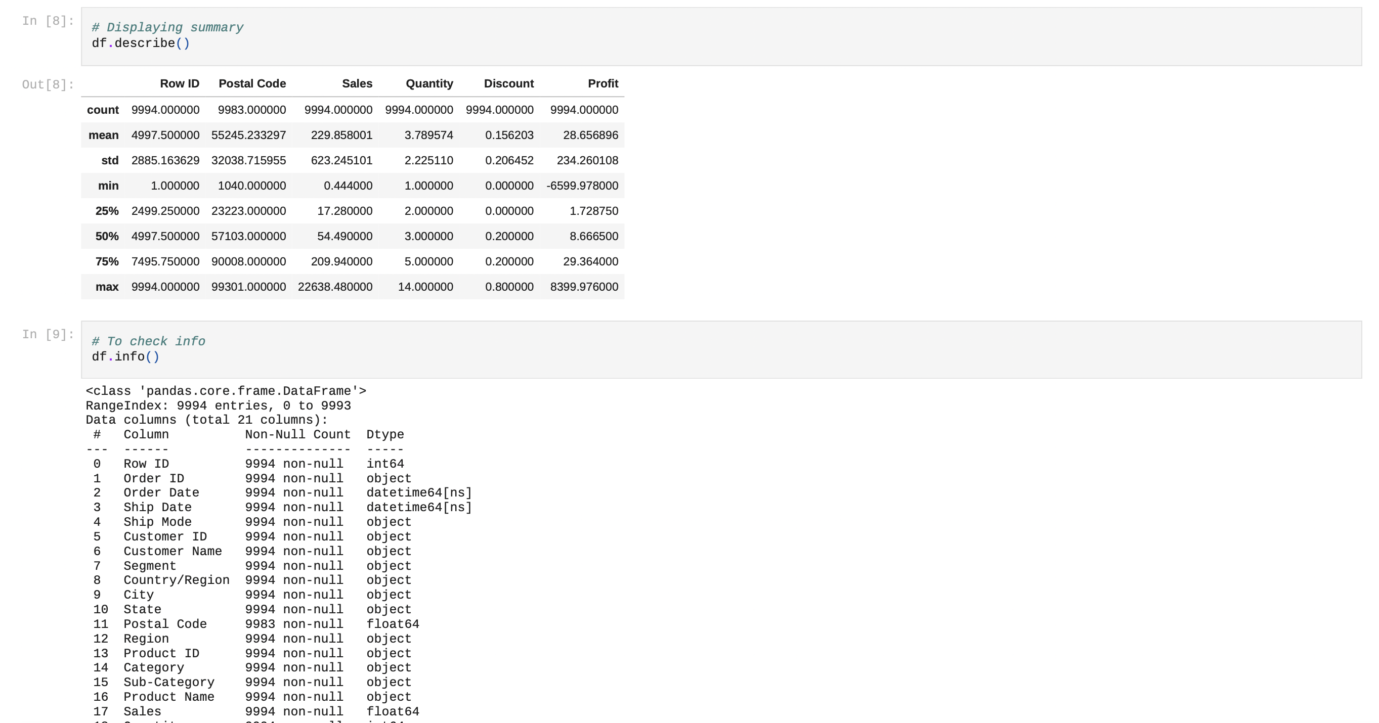

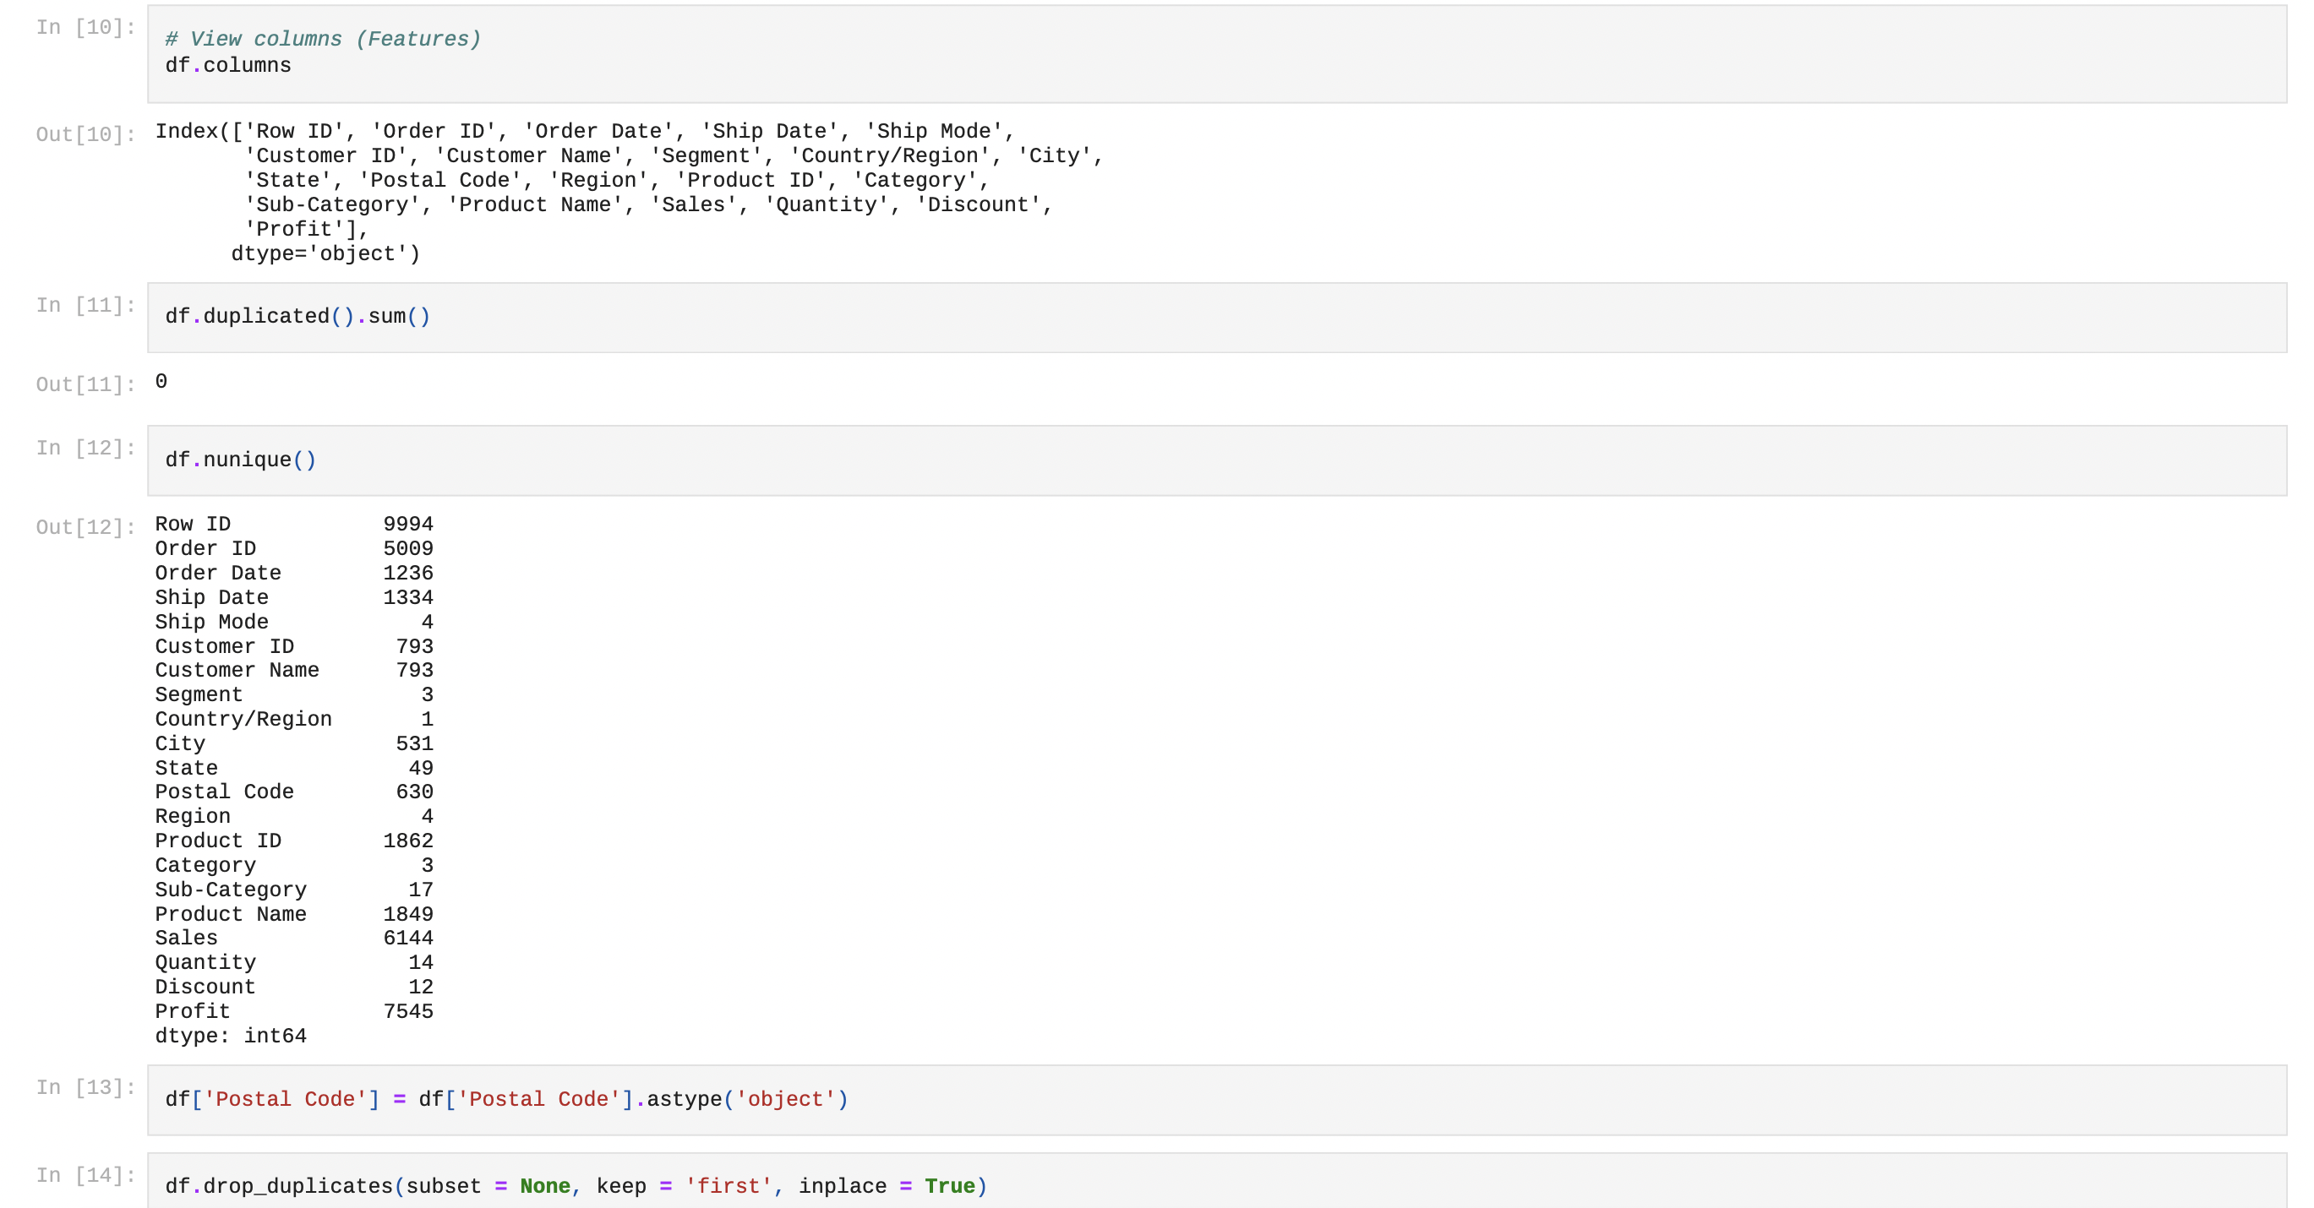

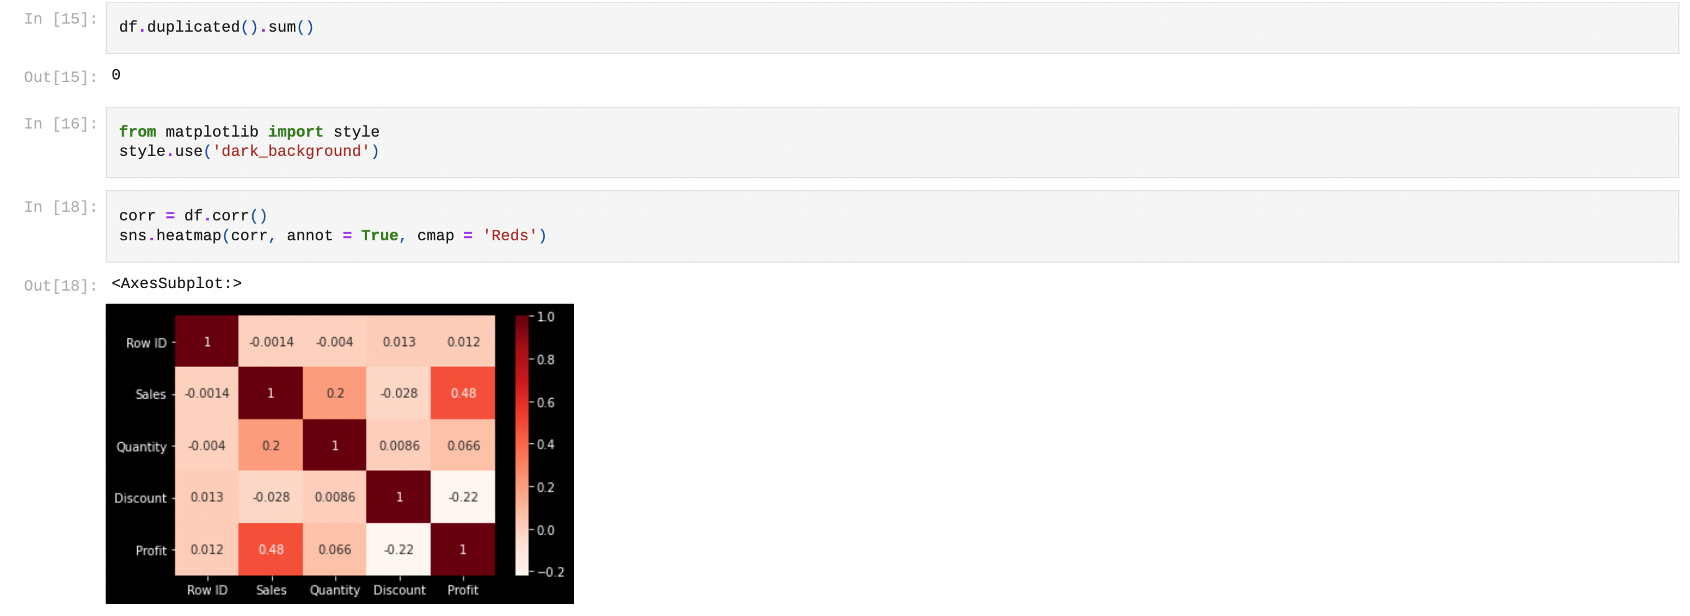

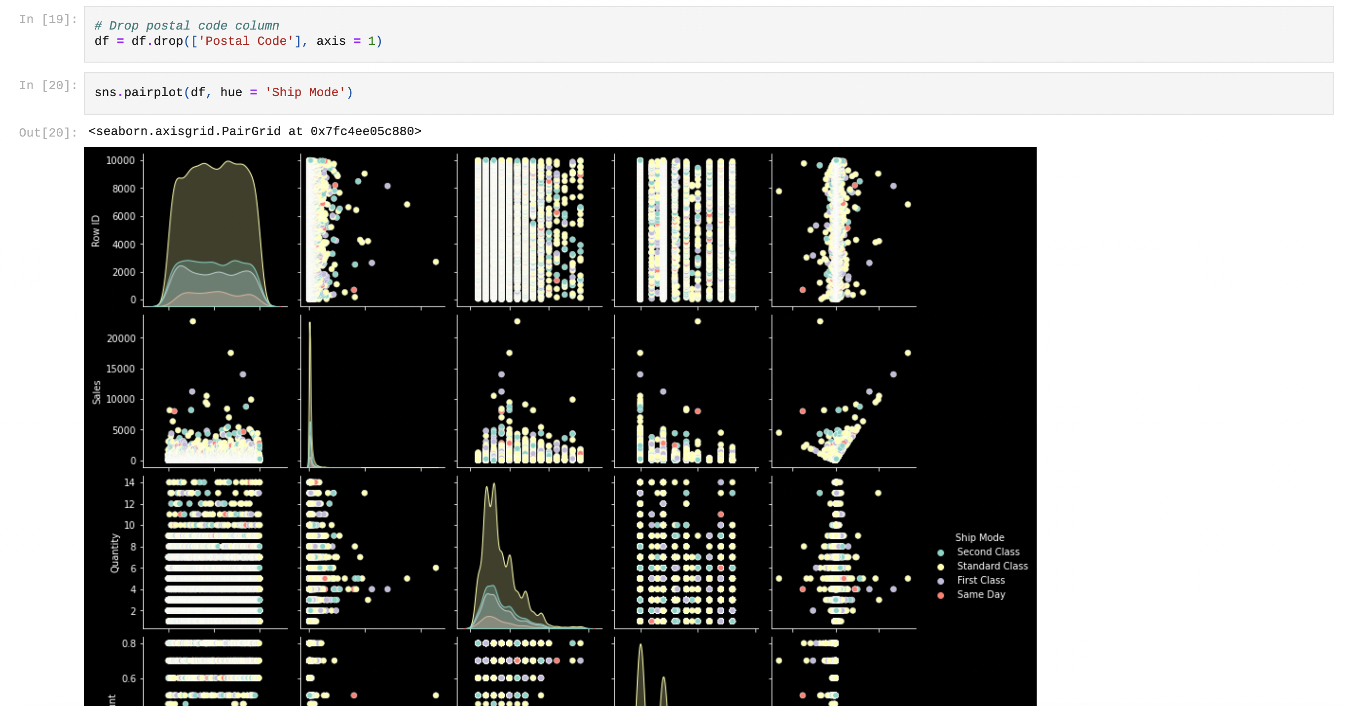

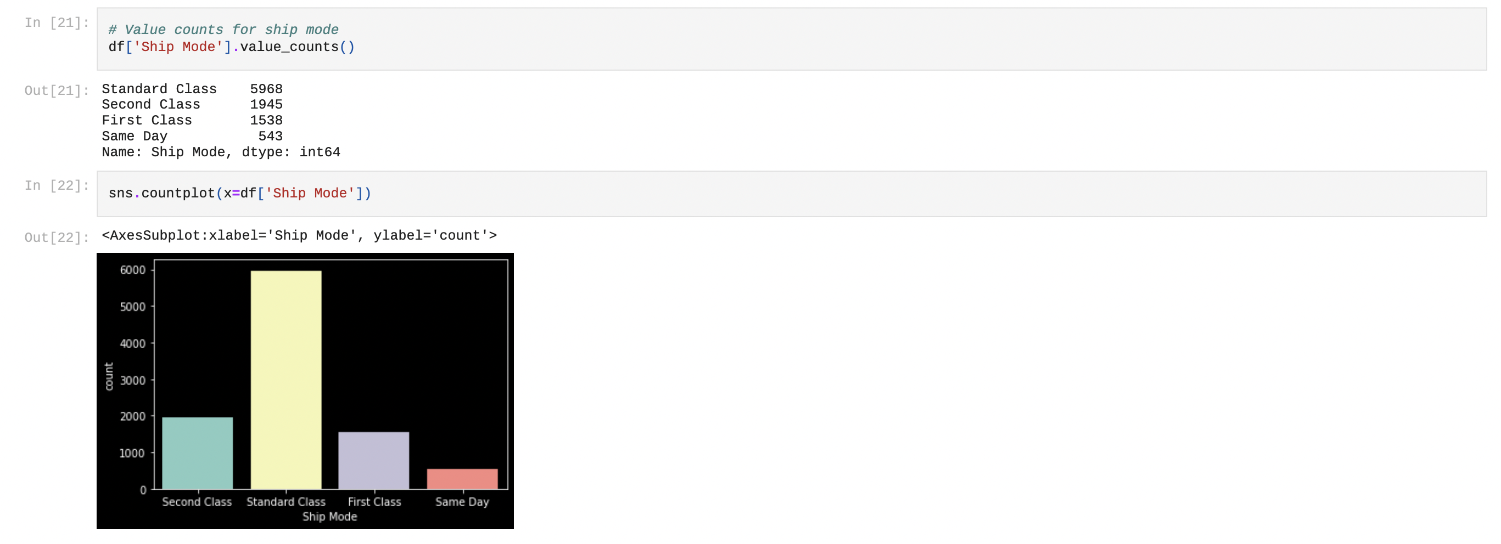

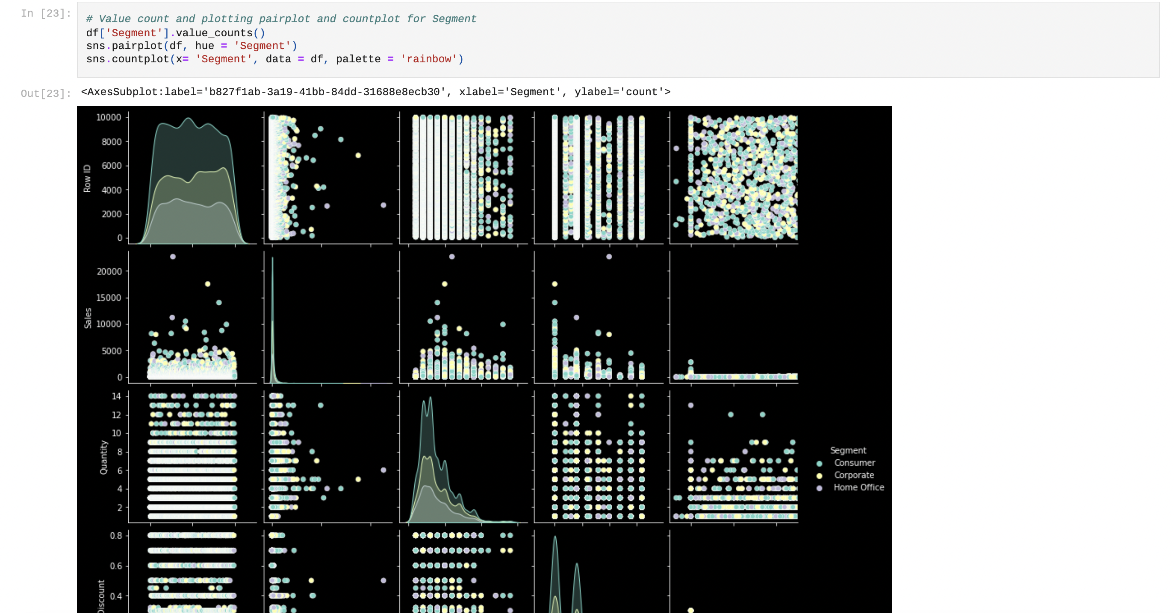

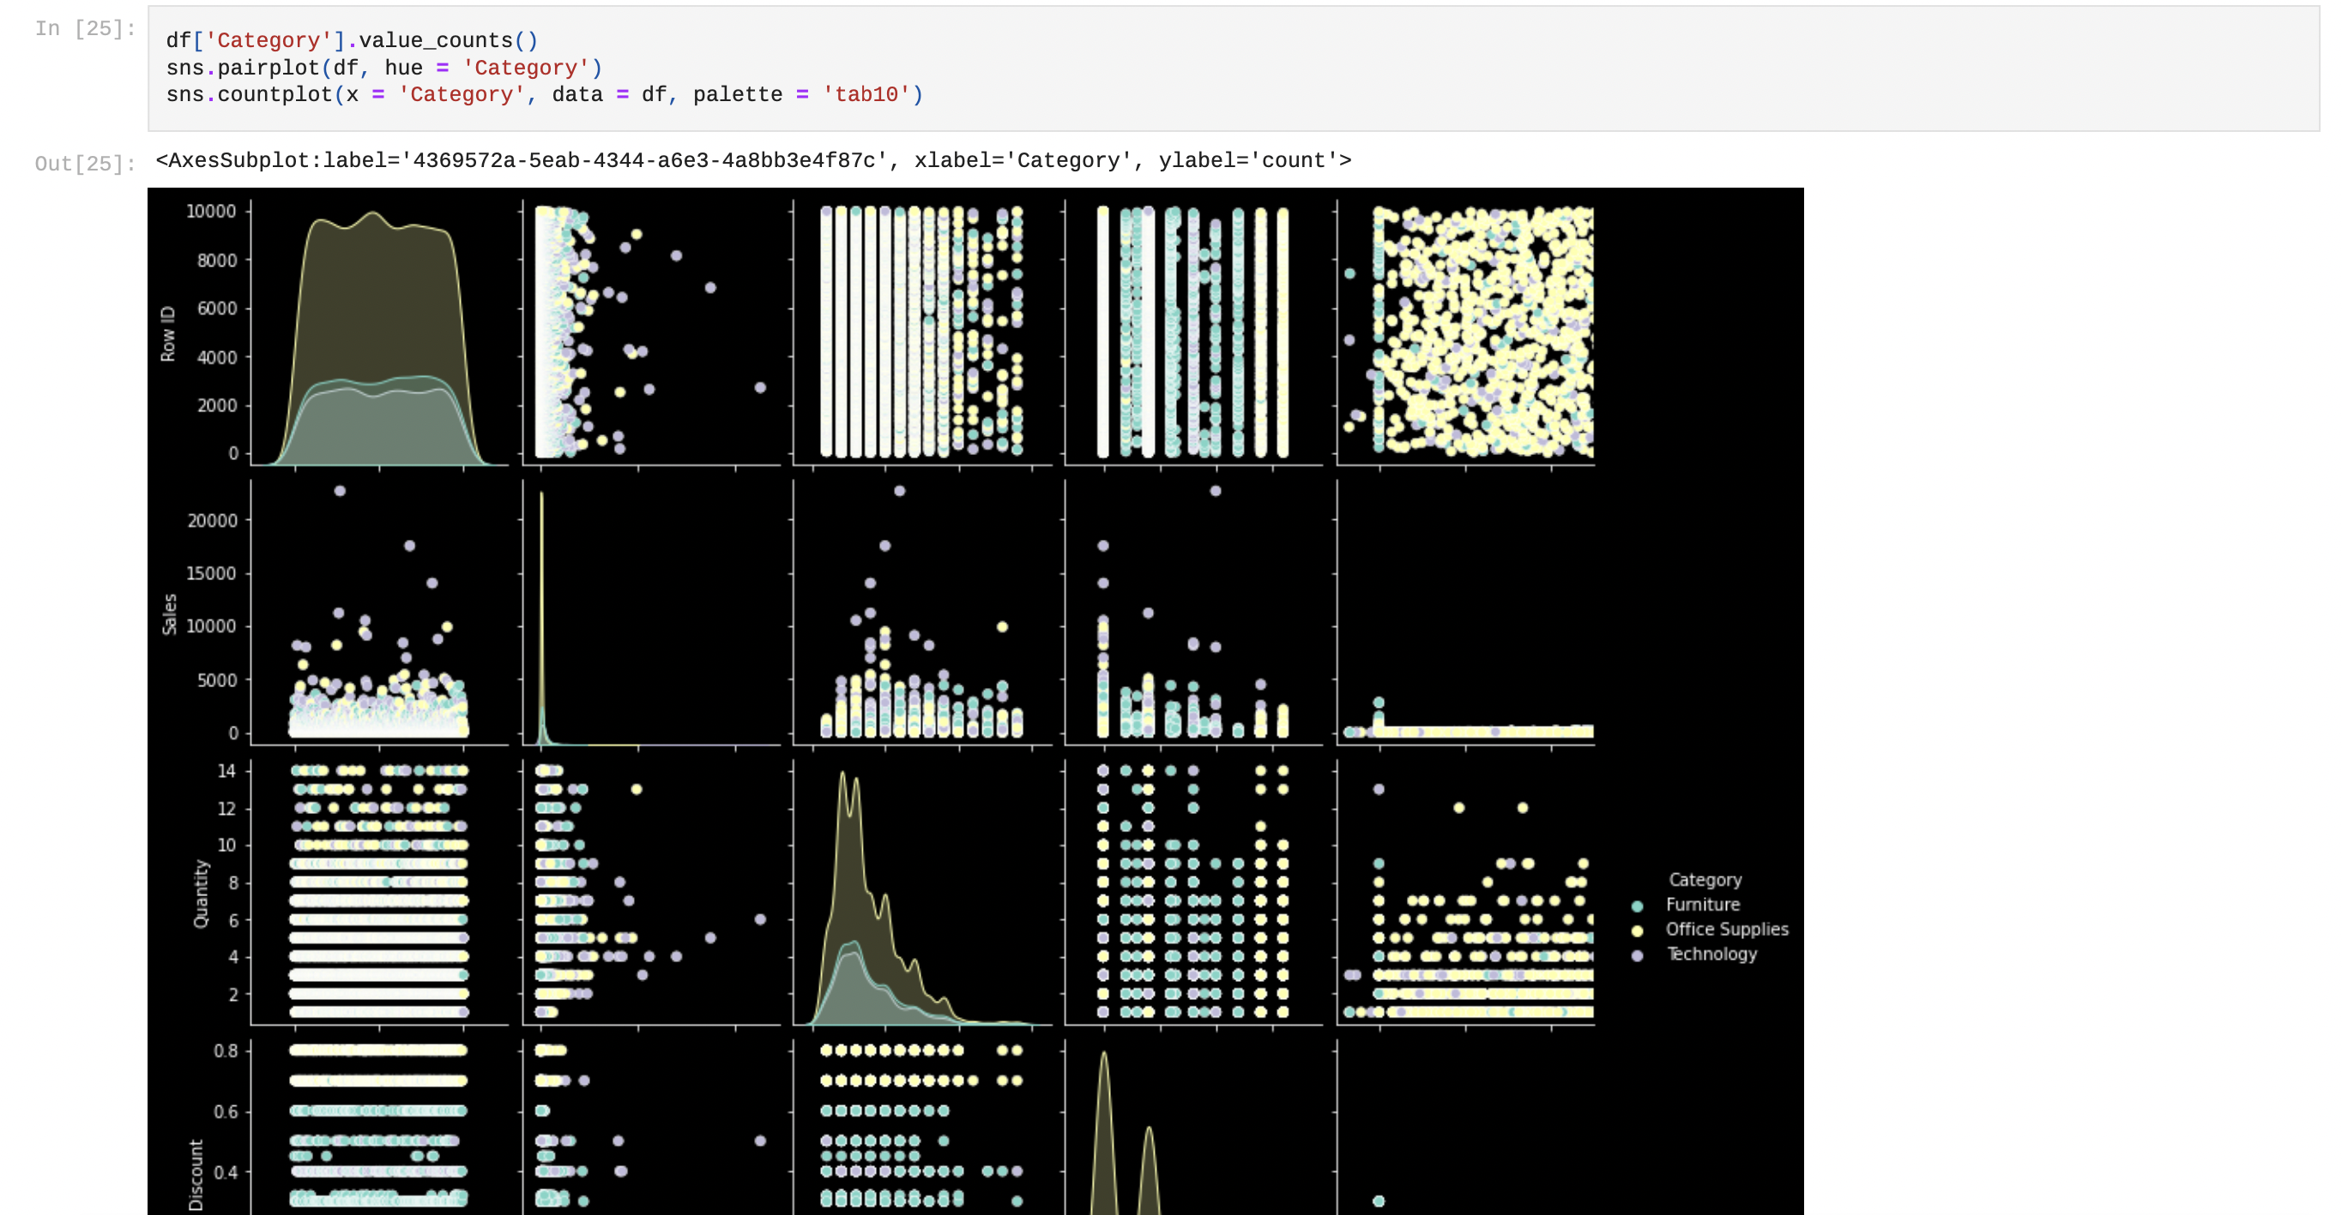

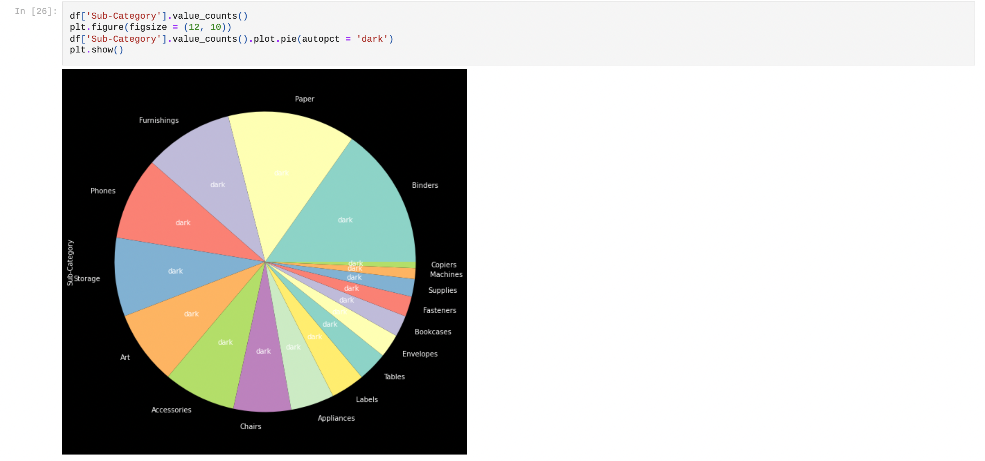

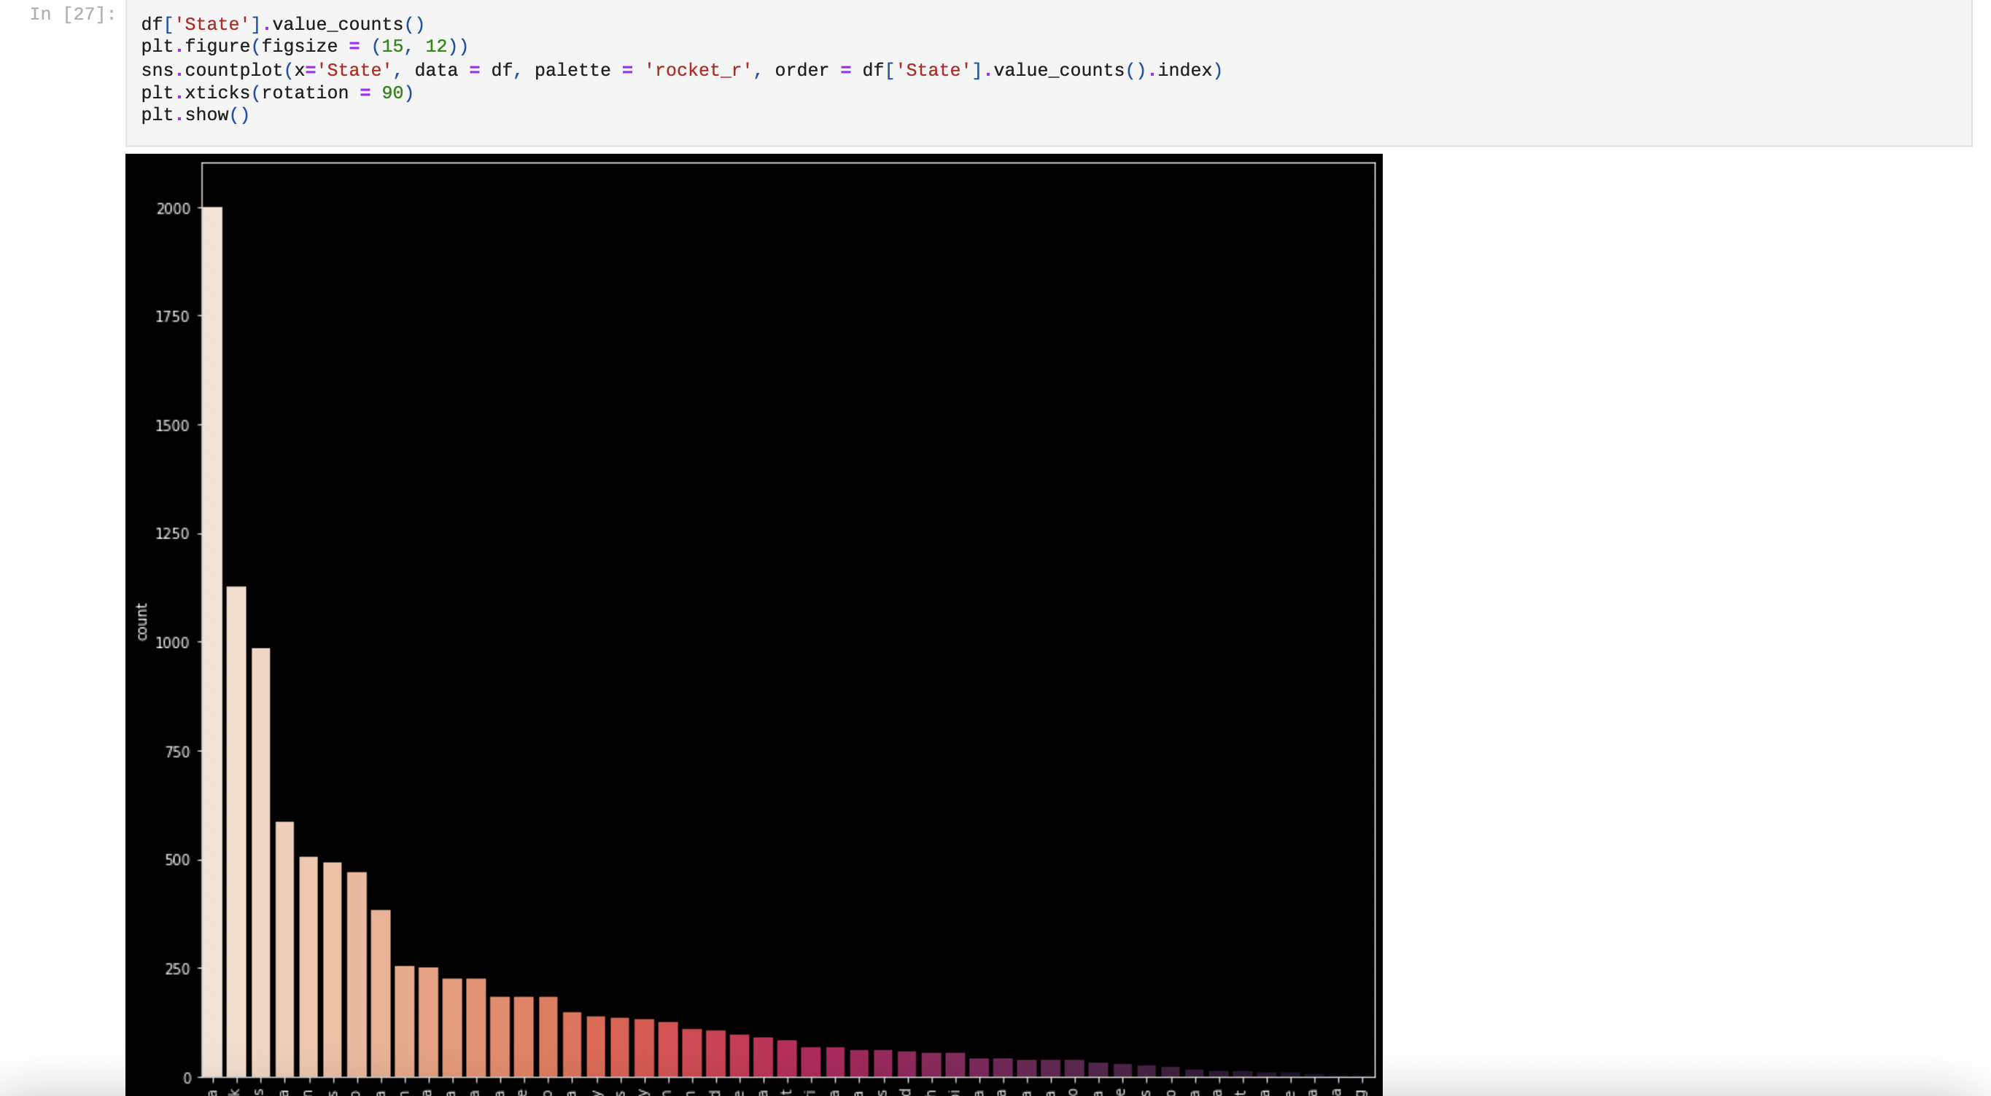

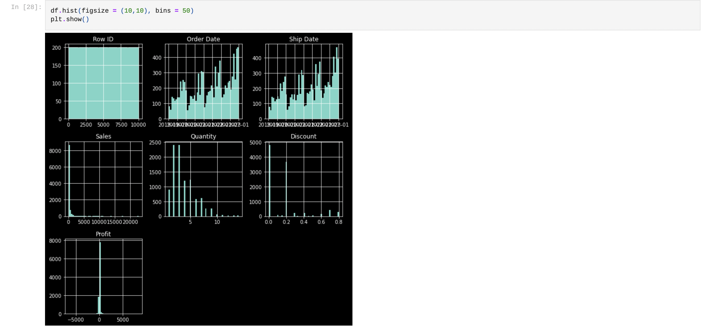

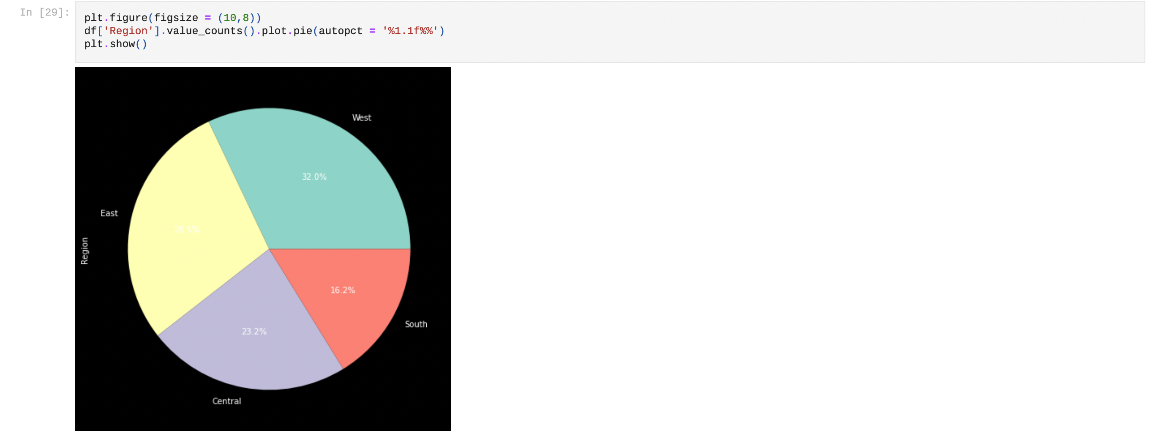

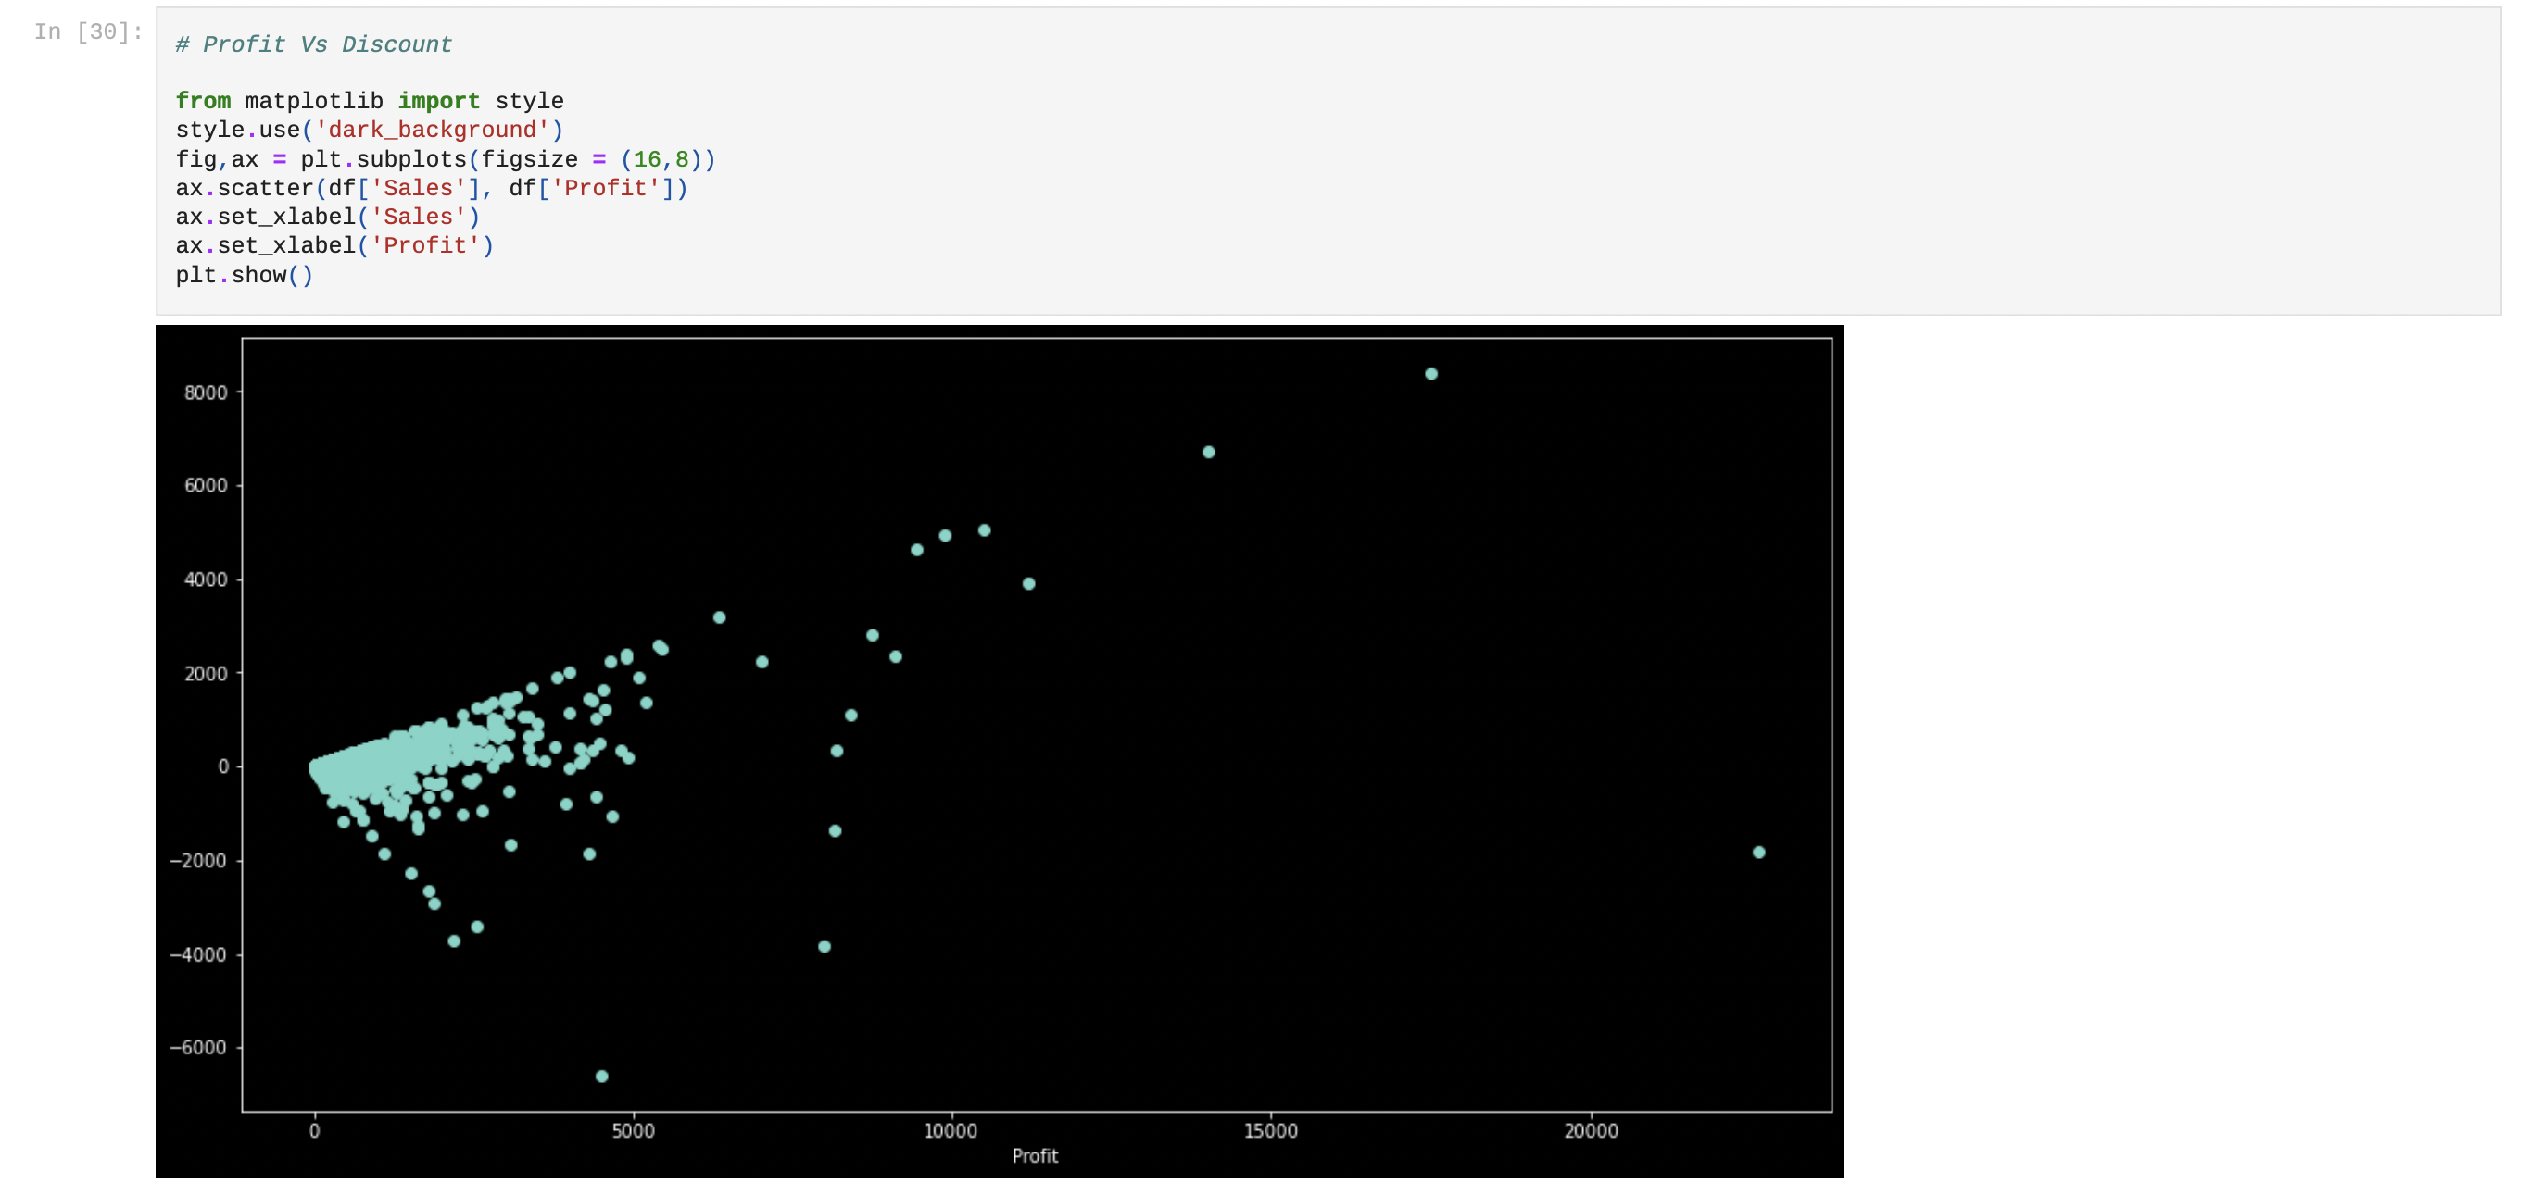

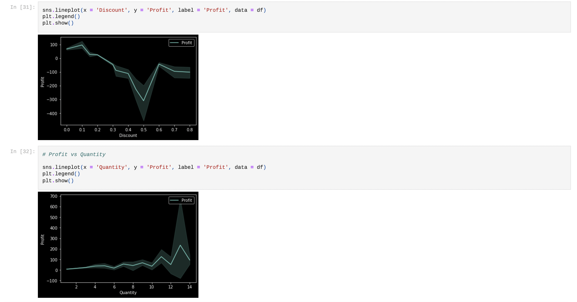

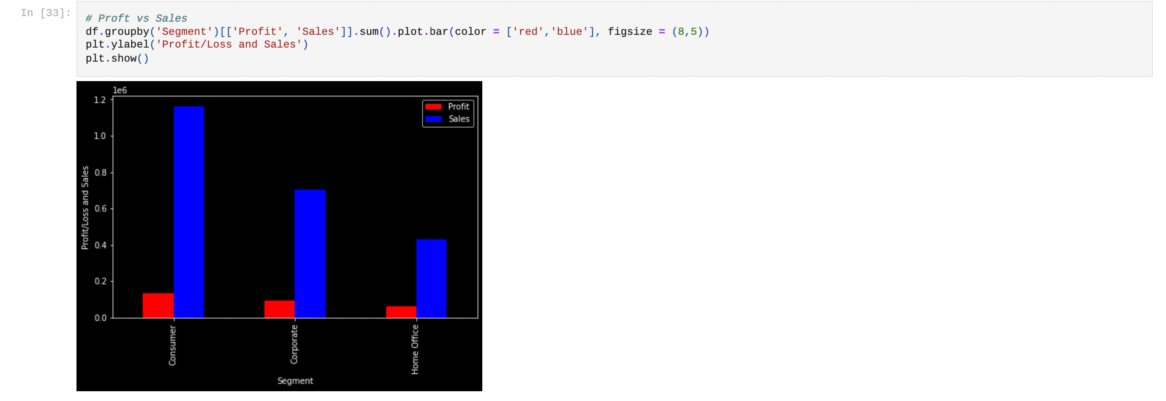

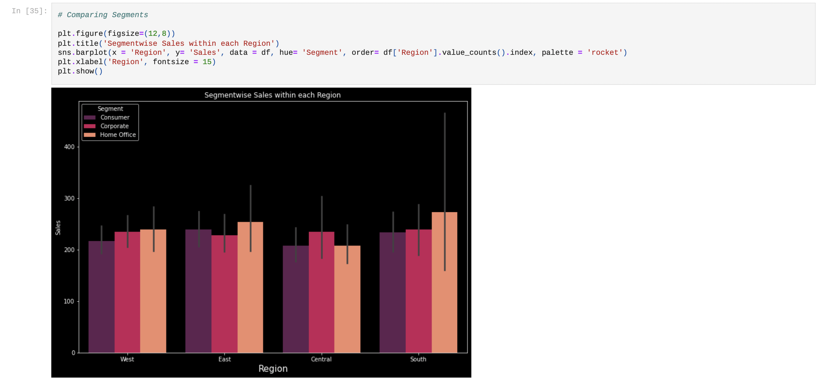

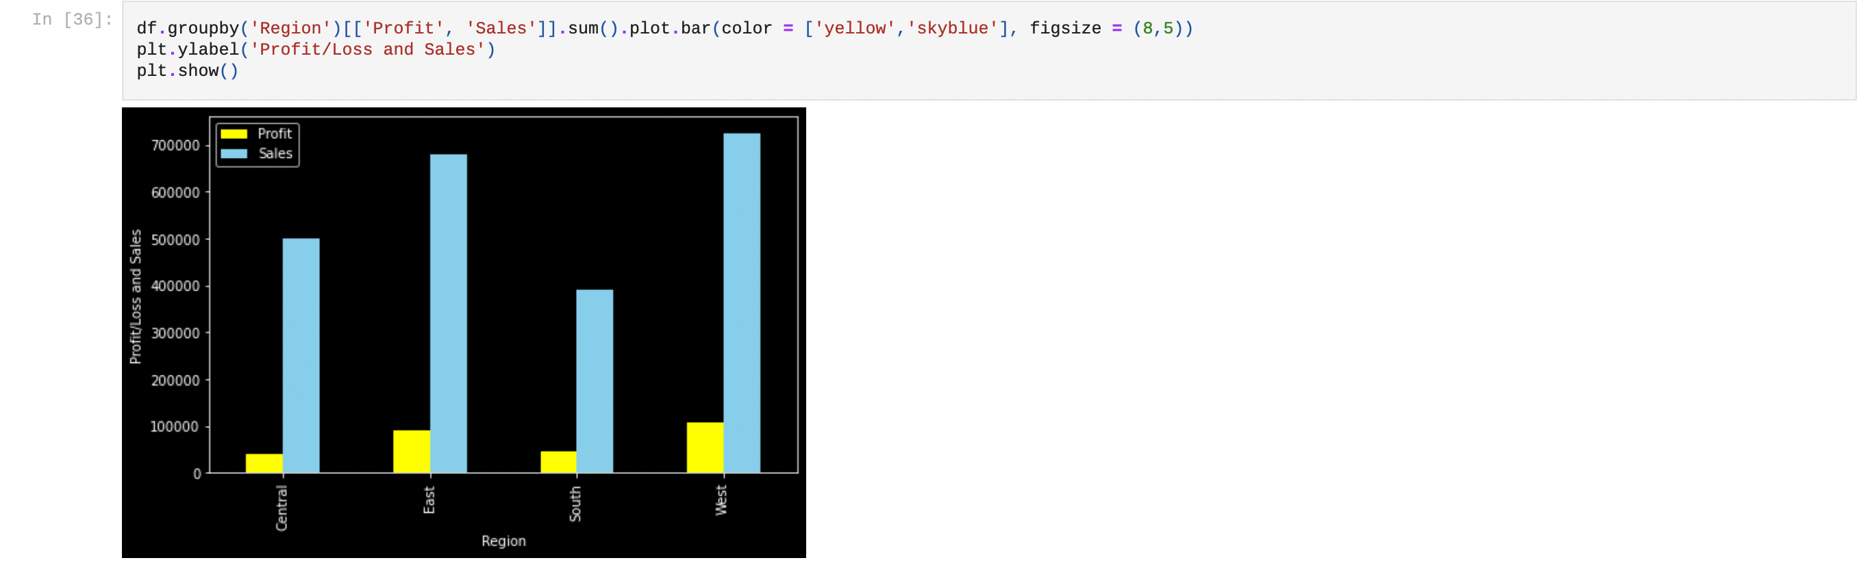

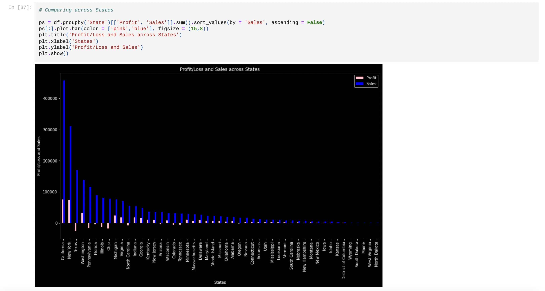

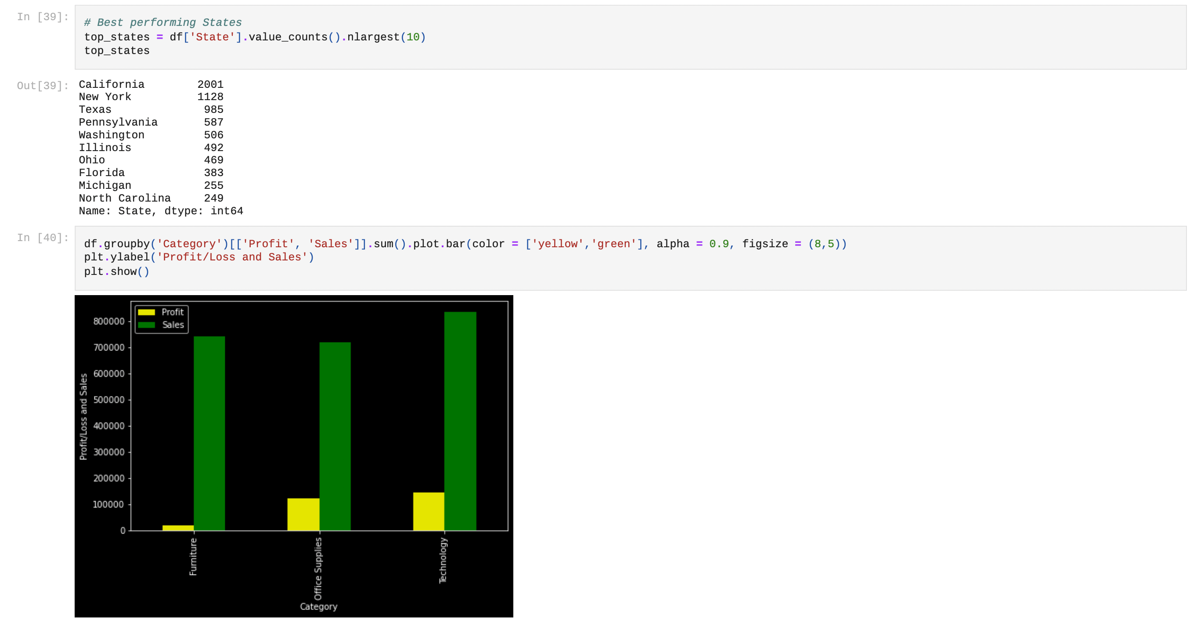

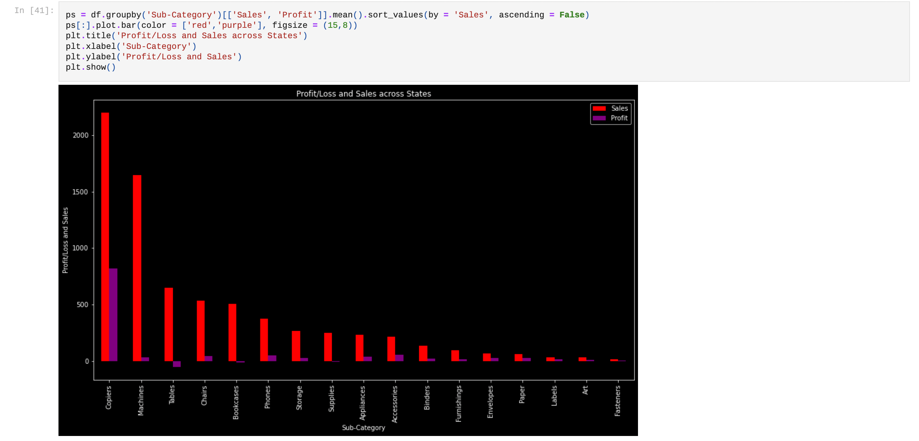

## Timeline

|  |  |
| --- | --- |
| Objective | Time |
| * Outlining Project Topic and Description | September 30, 2022 |
| * Drafting Project Questions and Objectives | September 30, 2022 |
| * Performing Exploratory Data Analysis | October 7, 2022 |
| * Final Project Proposal Report | October 11, 2022 |
| * Creating Dashboards and Story | October 31, 2022 |
| * Building Machine Learning Model | November 21, 2022 |
| * Final project report | November 28, 2022 |
| * Final Project Presentation | December 7, 2022 |

# Data Pre-processing and Modelling

## Problem Statement

Maintaining the right amount of inventory at right time is very important for our store as it reduces the cost related to storing, shipping etc. To maintain the right amount of inventory we need to predict the requirement by analyzing the past data, here, we are building multiple machine learning models (Regression) to predict sales in future and concluding with best generalized model.

## Data Description

The data table is a book record of sales, orders, and profit for each day.

The raw data table consists of 21 features and 9995 records. The features are:

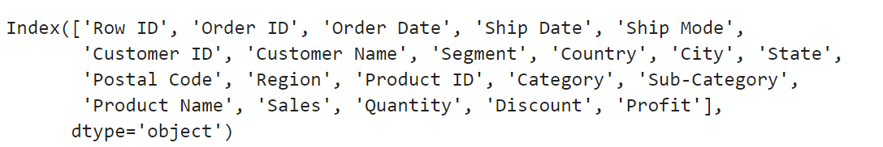

* Here we are using some of these related features to train and test the model for sales prediction.

# Data Pre-processing

## Null checks

* We are starting pre-processing by checking for null values in the table.

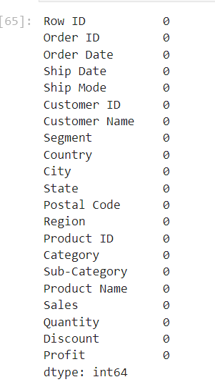

* The table does not have any null values.

## Dates Extraction

* The table have Order date and Ship date as standard format (month/day/year), but for our analysis we need each one separate. We split the Order date and ship date and assigned month, day, year to new features as (Ship_Date, Ship_Month, Ship_Year, Order_Date, Order_Month, Order_Year).
* After dates extraction, we have dropped the Order date and Ship Date feature as this data has present in another features. After modifications the data frame consists of 25 features.

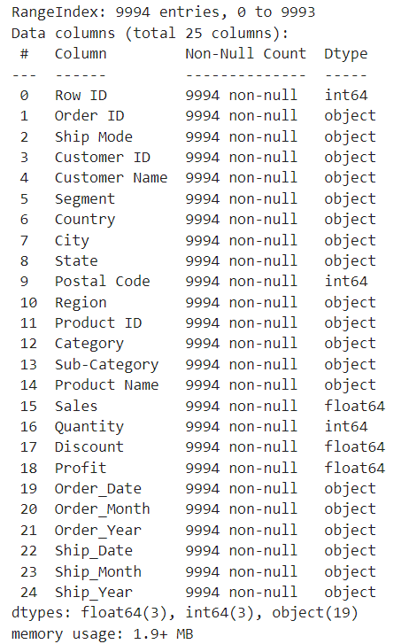

* The new features are object type, these needs to be converted to integer type for computation and analysis. After changing the data type the features description is like.

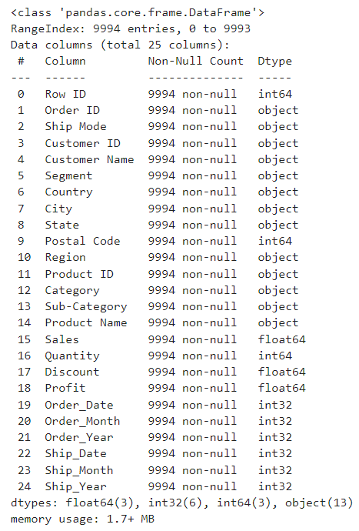

## Label encoding

* The data frame consists of many features that have string values (Country, City, State, Postal, Region etc.). Regression models performs better when they deal with numeric values, we are encoding some of these features for their unique values, assigning numeric value starts with 0.
* After Label encoding to the State feature, the unique values for state are 1 to 49 as US have 50 states.

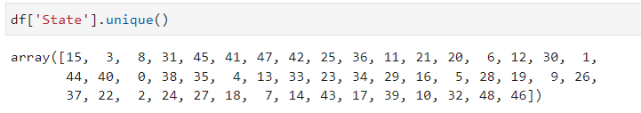

## Feature Selection

* To get the better result from model, we need to provide the features that will contribute more for predicting the target value. We dropped some of the features from data frame as those would not very effective for prediction in here.
* After dropping the features that would not bring more value, the data frame consists of 14 features

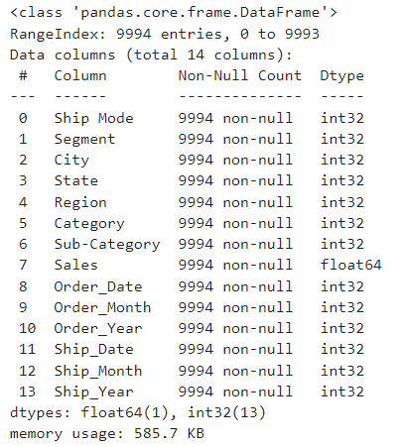

## Target Feature Description

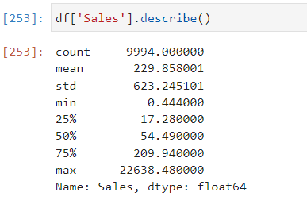

* The sales feature has mean around 230, maximum sales is around 22638, maximum value is very far from the mean, we search for outliers and 16 records has sales value more that 6000 as these would impact model score, we have dropped these 16 records from data frame.
* After dropping the records.

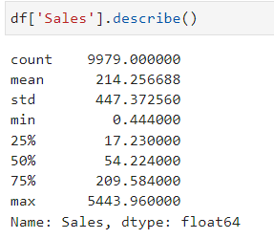

## Data Split

* We are considering the sales feature as target and will use remaining 13 features to predict the target value.

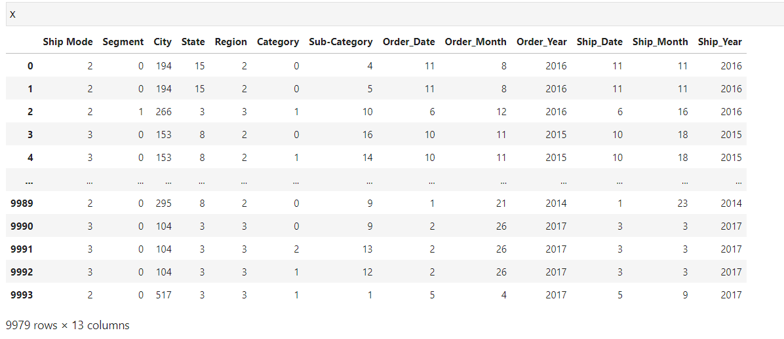

## Scaling

* The values in the above features are in different scales, it would help model result if the data were in same scale, here we are rescaling the values using standard scaler with mean value ‘0’ and standard deviation 1.

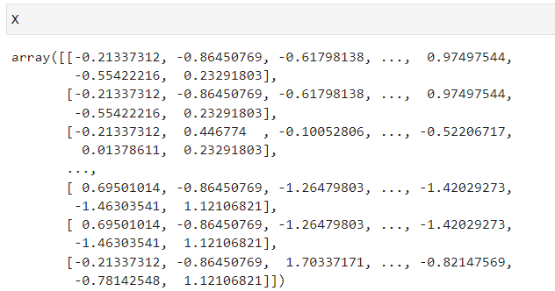

* Similarly, we have rescaled the target feature, after scaling the values are between -1 to 1.

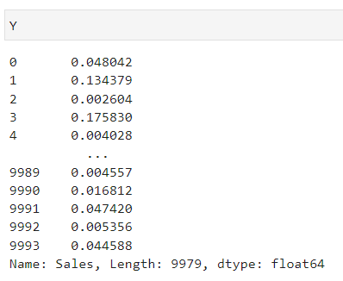

# Modelling

We had prepared the data for modelling in the data pre-processing step, before fitting the data to the model, first we need to split the data into two sets (training data and test data). Wil train the model with training data and test with test data will compare the results and will conclude the model performance.

## Linear Regression:

As the problem statement is about prediction, it would be good starting with linear regression model.

**Metrics:** - to evaluate model performance we are using two metrics one is coefficient of determination (R2) and mean squared error (MSE)

Coefficient of determination (R2) would indicate the proportion of variance in target value is explained by the variance of remaining other features.

Mean Squared Error (MSE) would indicate the average of squared errors (error means predicted value – actual value).

### Result & Conclusion

* The training results

|  |  |
| --- | --- |
| **Coefficient of Determination (R2)** | 0.007907005321866278 |
| **Mean Squared Error (MSE)** | 0.006828861311600397 |

* The test results

|  |  |
| --- | --- |
| **Coefficient of Determination (R2)** | 0.006036317837987637 |
| **Mean Squared Error (MSE)** | 0.006196011748475083 |

* The error is very less in both the results but R2 is also very low, the model is not yielding good results, will use cross validation to counter overfitting, if there is any.

## Cross Validation

Cross validation would help tackling the overfitting problem as it would folds the data into multiple segments and will use some for training and some for testing and provides the score.

### Results & Conclusion

The CV score with 10 folds

|  |  |
| --- | --- |
| **Coefficient of Determination (R2)** | 0.0024886997615992446 |
| **Mean Squared Error (MSE)** | 0.0445622070262723 |

* The cross validation has not improved the results as there is hardly any change in R2.
* Will use some shrinkage models to tune the parameters.

## Shrinkage Methods – Ridge Model

Shrinkage methods would help to solve the overfitting and underfitting if there is any by tuning the some of the parameters. Ridge is one of the shrinkage method models.

### Results & Conclusion

|  |  |
| --- | --- |
| **Cross validation Score (error)** | 0.0446 |

* The error is very close to the previous value, so this model is not improved the performance much.

## Lasso Model

Lasso is one of the shrinkage method models, would help in minimizing the overfitting and underfitting.

### Results & Conclusion

|  |  |
| --- | --- |
| **Cross validation Score (error)** | 0.0449 |

* The error is very close to the Ridge model, Lasso has not improved the performance in this case.
* The Shrinkage method models are not very helpful to improve the performance.

## Huber Model

* As Shrinkage method model are not very effective for this kind of data, will try with Robust Huber model, it is robust to outliers.
* Regression function would lean more to outliers, it would be great to use the robust model.

### Result & Conclusion

|  |  |
| --- | --- |
| * **Cross validation Score (error)** | 0.0356 |

* The error is very less compared to the shrinkage method model, will test the same model with test data.

The test results

|  |  |
| --- | --- |
| **Coefficient of Determination (R2)** | 0.10 |
| **Mean Squared Error (MSE)** | 0.08 |

* The Huber Model has improved the performance, by increasing the R2 to 0.1 but similarly error also has also increased by significant margin (0.006 to 0.08)

## XGB Model

* Extreme Gradient Boosting (XGB) is a tree-based model, that deals with large number of records. As we are dealing with around 10000 records, it would be ideal to try with this model.

### Result & Conclusion

* The training results

|  |  |
| --- | --- |
| **Coefficient of Determination (R2)** | 0.4805813306714204 |
| **Mean Squared Error (MSE)** | 0.003575308035162236 |

* The test results

|  |  |
| --- | --- |
| **Coefficient of Determination (R2)** | 0.15193455769393605 |
| **Mean Squared Error (MSE)** | 0.0052865346473973136 |

* XGB model has given very good results as it has decreased the error from base model (Linear Regression) and has increased the coefficient of determination (R2).

## Models Comparison

**Training Results comparison**

|  |  |  |
| --- | --- | --- |
|  | **Linear Regression**  **(Base Model)** | **XGB Model** |
| **Coefficient of Determination(R2)** | 0.007907005321866278 | 0.4805813306714204 |
| **Mean Squared Error (MSE)** | 0.006828861311600397 | 0.003575308035162236 |

**Test Results comparison**

|  |  |  |
| --- | --- | --- |
|  | **Linear Regression**  **(Base Model)** | **XGB Model** |
| **Coefficient of Determination(R2)** | 0.006036317837987637 | 0.15193455769393605 |
| **Mean Squared Error (MSE)** | 0.006196011748475083 | 0.0052865346473973136 |

* By comparing all the models XGB yields the best results for this dataset, so we would use the same model to predict the sales in future and will provide insights to maintain the inventory.

# Dashboards and Story

When working with data, it is oftentimes difficult and occasionally impossible, to determine the pattern, the behavior, or the story that our data is telling us before we perform any analysis. This is why we use visualizations and stories to present the truth that lies within the data. Whilst statistics can sometimes be misleading; our visualizations detail each angle presented by the data in a raw, unmodified way. We take the truth within the numbers and display it in a way that any person within a business or company may easily follow and understand the outcomes of our data analysis.

Through our exploratory analysis we had yielded some interesting topics and thoughts about what our data is telling us. We used these ideas to guide our decision making when it came to which findings to highlight in our dashboards.

The following section includes screenshots, our notes and our findings based upon our research and analysis of the superstore dataset.

# Executive Overview

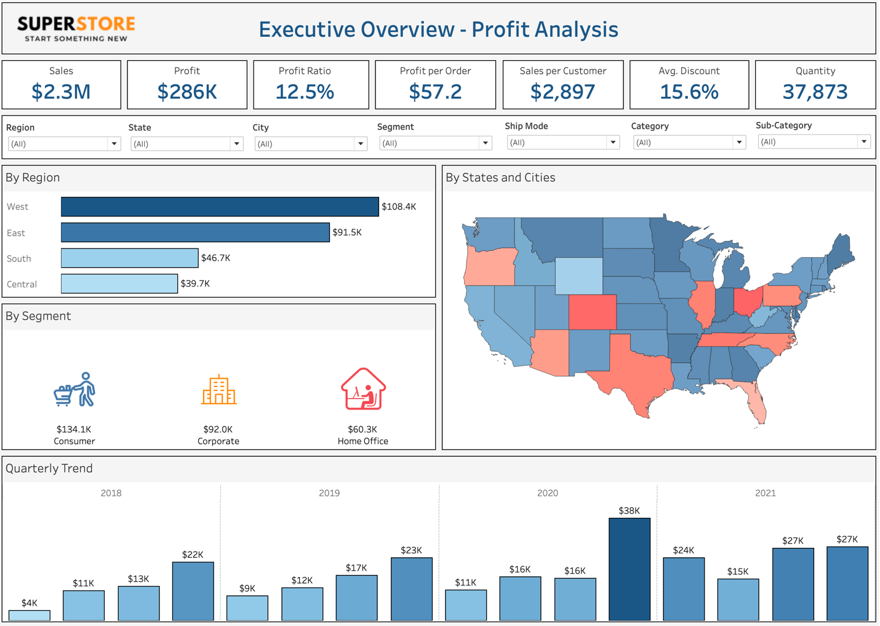In this dashboard we display the KPI’s; including **total sales, total profit, profit ratio, discount and quantity sold,** a brief geographic breakdown of figures, the quarterly trend and an exploratory analysis of the segments, categories and individual customers that were best performing. This dashboard can be filtered on numerous features so that many different stories may be told.

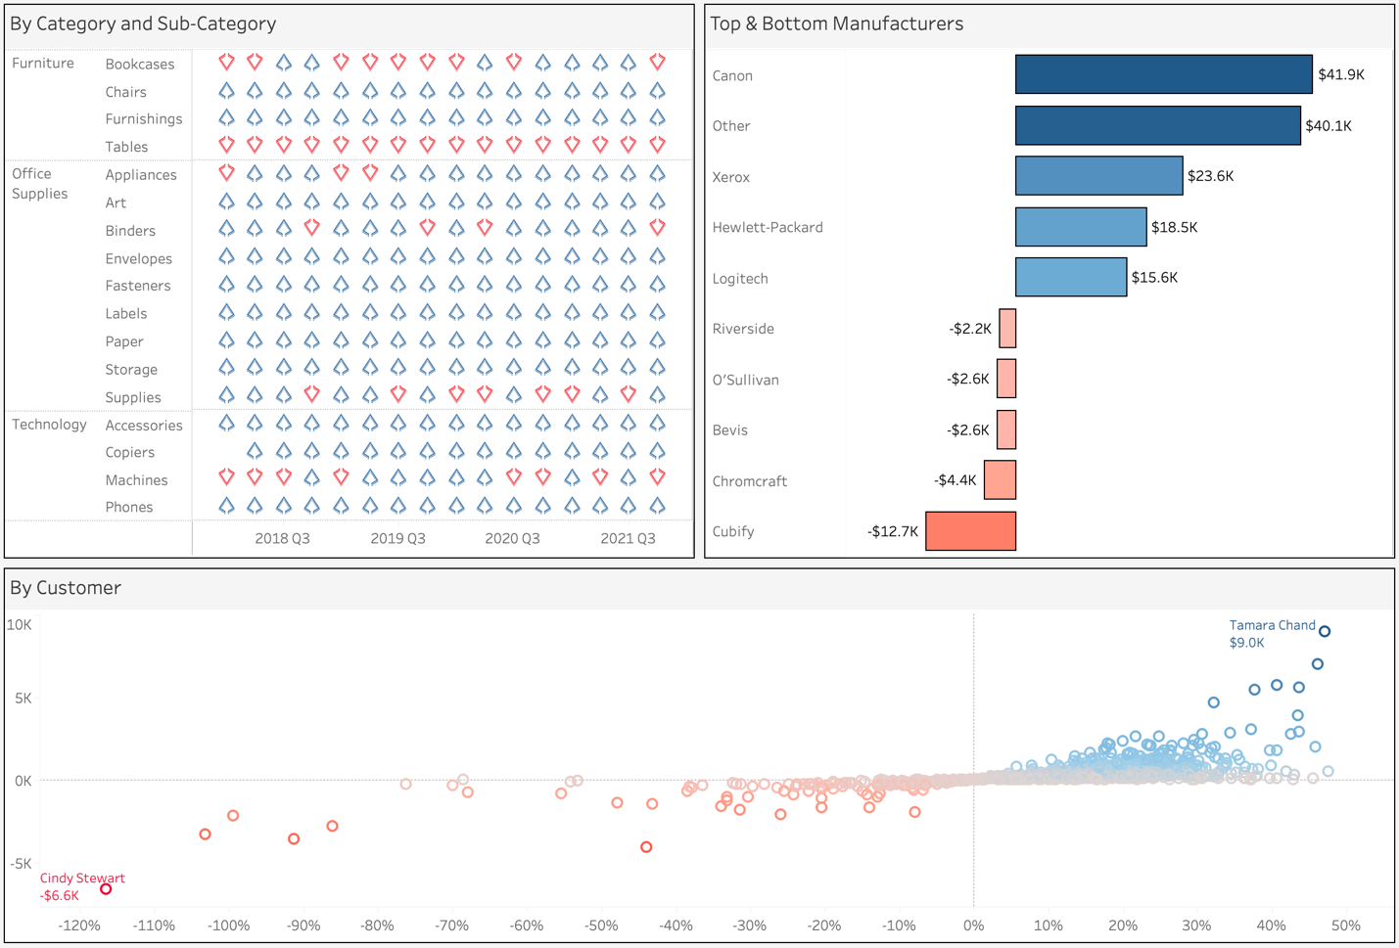

* From the data we were able to determine that the west is the most profitable region with 37.9% of all profits coming from these states
* Our direct-to-consumer segment is the largest with 46.9% of profits coming from these sales
* From the map we can see that Ohio is the lowest performing state with a profit ratio of -21%
* In each year the best performing quarter was the last one; perhaps due to Christmas sales with November and December consistently having the greatest quantity of sales

# Sales Performance

This dashboard serves to tell the story of Superstore’s sales. With a focus on the spread of sales; geographically and by consumer. Through this dashboard executives are able to see where and who buys the greatest value of product as well as the type of products that they are buying.

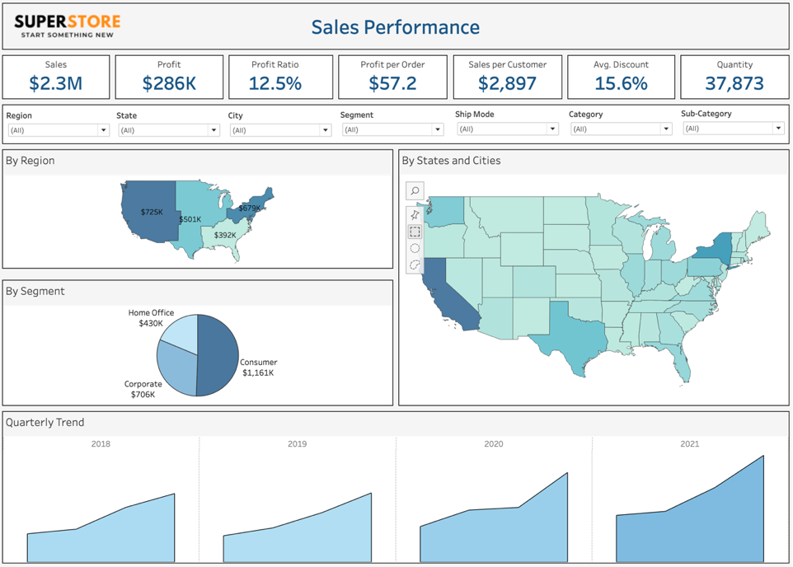

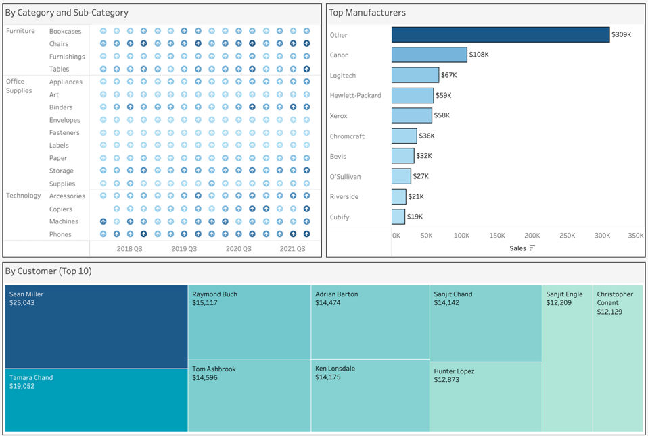

* From the visualizations it is clear that the west provided the largest proportion of sales
* The best-selling sub-categories were chairs (furniture), binders (office supplies) and phones (technology)
* The top customer (Sean Miller) was an outlier; having spent $6000 more than the second-best customer (Tamara Chand)

# Regional Analysis

The goal of this dashboard is to breakdown and analyze the sales, profits, and trends through a geographic lens. Here we aim to explore the data using the filter of location. Through doing this we learned what items sell best in what locations, the balance and accessibility of our platform and where we can find our best customers. This information will help to determine our growth strategy as we move forward.

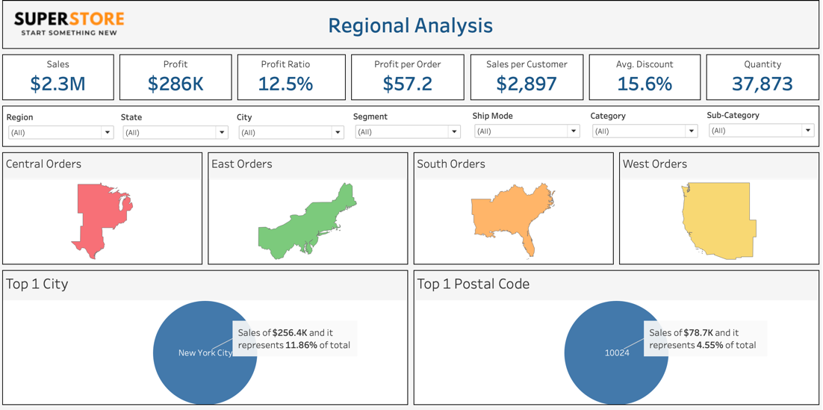

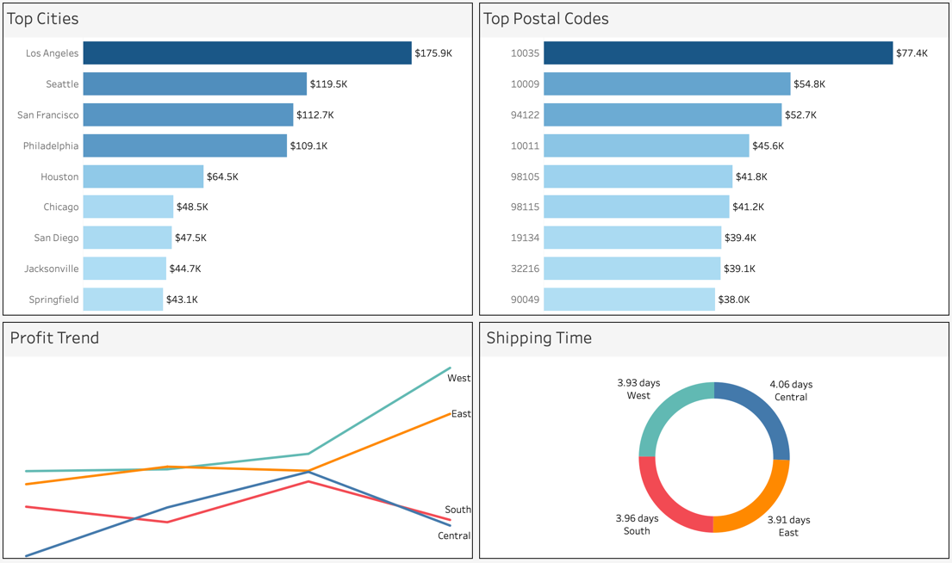

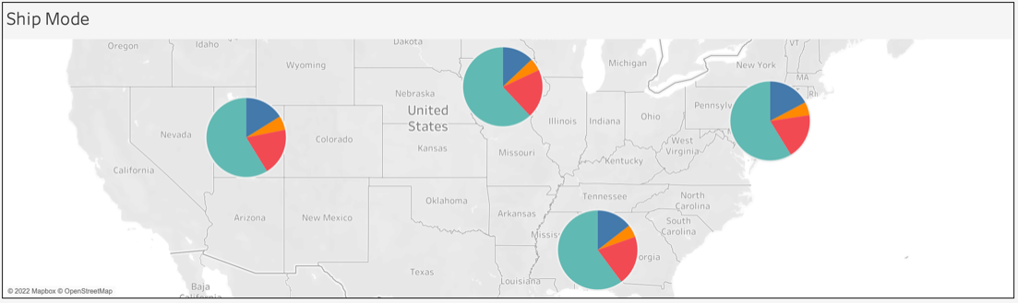

* The charts show that, whilst the West made the highest number of orders, the top city was actually New York City from the East region.
* Largely, as we expected, the orders come from major cities (LA, NYC, Chicago, etc.)
* All regions display the same pattern with respect to ship mode
* The East and the West markets have continued to grow through the years however the South and the Central markets will require some tailoring to ensure Superstore can capture the maximum number of consumers nationwide

# Customer Segmentation

This dashboard will highlight and help us to understand the behaviors of our customers. We want to learn about the patterns we can observe, the common characteristics of shoppers and from this information we can align our business strategy to best serve the consumer and grow the company.

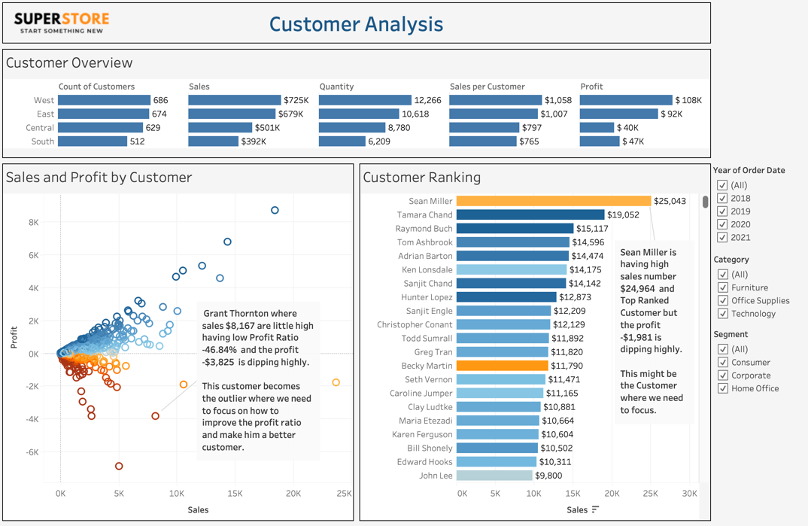

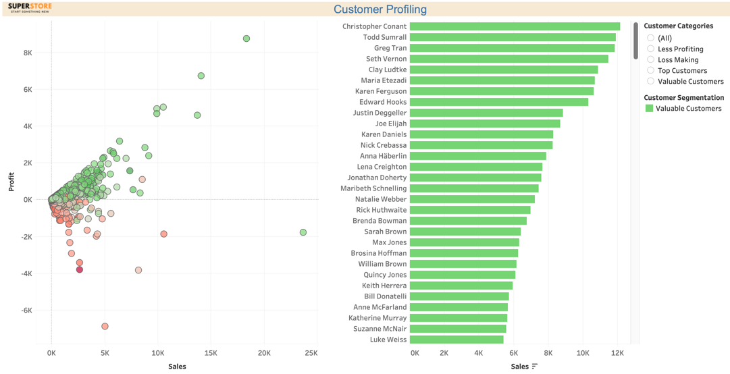

* We can see that the outliers can be our focal point; Grant Thornton (profit -$3,825), Sean Miller (sales +$25,043, profit -$1,981)
* We need to adjust our discount since both of these customers are negatively affecting our profits
* We can also look towards Tamara Chand as an example of where we would like customers to be (high sales, high profit ratio)

# Product Overview

This dashboard allows us to see the true breakdown and the performance of each product that Superstore sells. Through this analysis we are able to isolate individual products, or entire categories; that are either excelling or need refining. We will use this information with executives to outline strategies for business growth through improved product offerings.

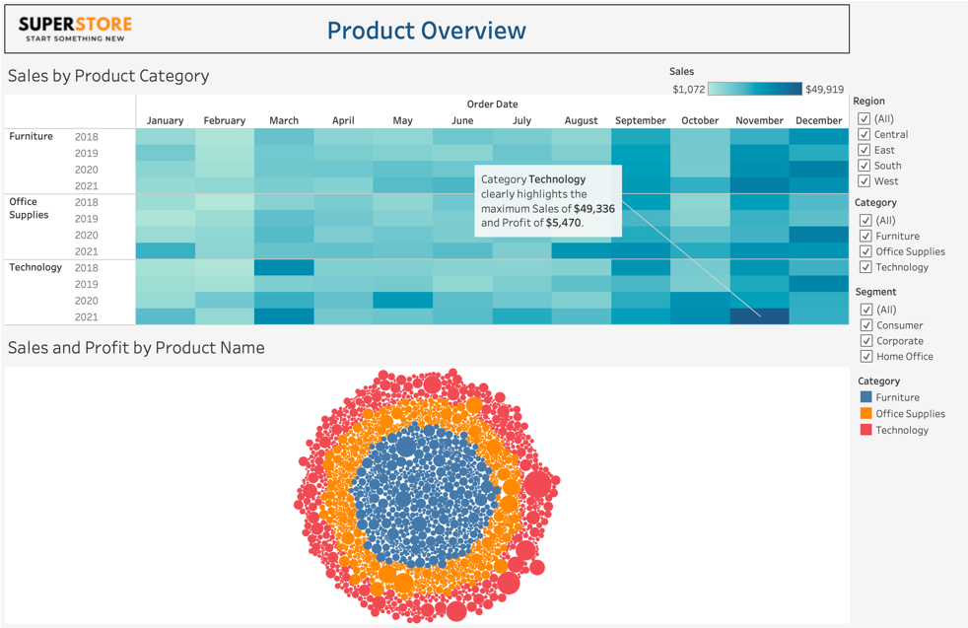

# Sales Forecast

From this forecast we are able to see predictions of how our sales will change over time with respect to their previous performance. This is very helpful in identifying whether or not there is a need for a drastic overhaul, or for minor tweaks to our strategy. For example, if this forecast were to predict declining sales across the board for Superstore, then we would have to reassess the plan as a whole and consider taking a different route. However, as indicated by the forecast, we can expect to see continued growth in each segment, with the exception of Home Office. This tells us that we may need to consider alternative strategies to promote the Home Office segment.

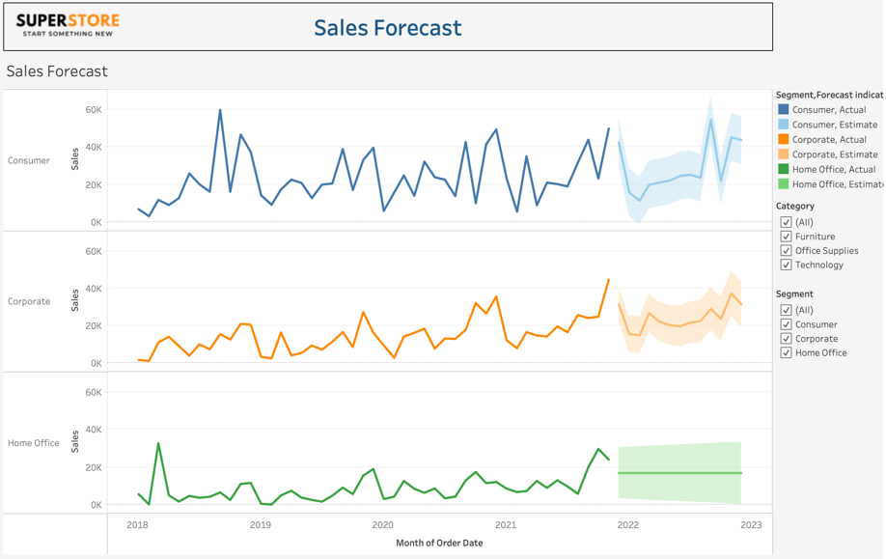

# Superstore Story

Through this presentation we aim to highlight the bigger picture. This story explains the key points behind our recommendations and provides concise information on the Superstore dataset. We detail customers to focus on, geographic regions to improve, categories and sub-categories that can help boost business growth and final recommendations to improve the business strategy.

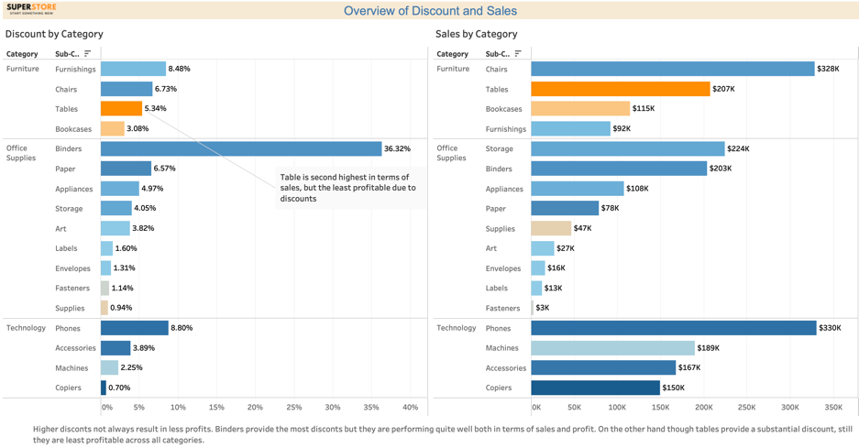

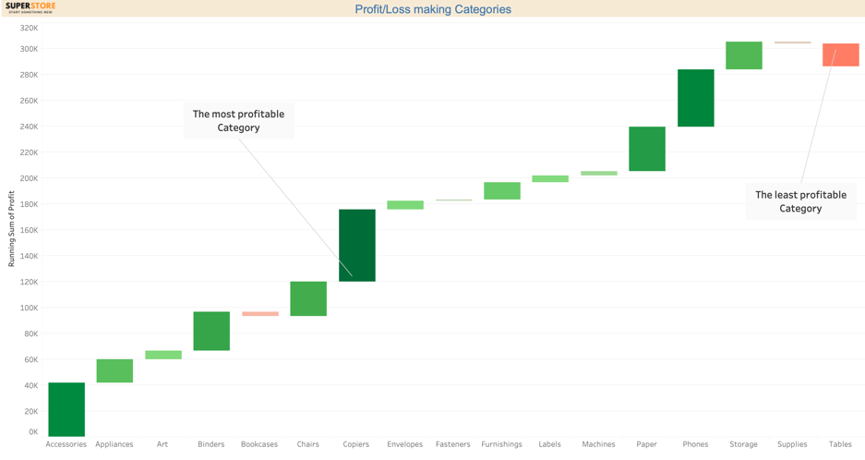

# Appendix:

